**Thoughts on broader appetite for energy stocks**.

In his latest post on Energy Musings, Mr. Allen Brooks ponders investor headwinds for energy stocks (but also how this could present an opportunity for investors in the sector as well).

*Will investors ever consider this an investable sector again? With the negative political rhetoric and government policies around the world becoming increasingly anti-fossil fuels, it is unlikely investors will be clamoring for energy stocks in their portfolios any time soon. As a result, market capitalizations will remain small, limiting the number of investable companies for major investment funds. A lack of market capitalization makes it difficult for portfolio managers to build investment positions without driving prices up substantially, cutting their profit potential. Therefore, they usually limit their buying to a handful of large market capitalization energy companies – mostly the large international oil companies, a few large exploration and development companies, and the three largest oilfield service providers.*

*Investor interest may grow as the reality that while Energy no longer sports a “growth” label, the fuel is not going away because the energy transition will prove to take longer and be more costly than many predict. With limited new capital going into the sector, oil and gas output growth will be restricted at a time when economic recoveries are driving demand higher helping to support and even drive oil and gas prices higher. Oil and gas price volatility further curbs investor interest in the sector, but that could change if and when the heralded super-cycle dynamics begin to play out.*

*Investing in Energy is even more challenging because of the political headwinds that are stronger than ever. If Energy company managements maintain the financial discipline they have exhibited for the past several years, shareholders will be well-rewarded through modest earnings growth, larger share buybacks, and increased cash dividends. This combination may lead to Energy’s performance being better than expected by those portfolio managers who are shunning the stocks. As their investment performance lags behind those portfolio managers who invest in Energy, they may be forced by investor demands to reallocate money into Energy. This is not a wish, but rather a possible scenario.*

*Source: Vanguard, Allen Brooks*

The following is recent commentary from **Goehring & Rozencwajg**. Risk the Peak Oil thesis as you will, but interestingly recall “Maturing Asset Base” was referenced as a “drag on crude oil and natural gas production growth” by US producers in a recent Dallas Fed Survey.

*While Hubbert’s predictions look ridiculous when considering total US liquids production, focusing only on conventional crude production suggests Peak Oil is alive and well. Last year, the US produced 3 m b/d of conventional crude oil – 7 m b/d or 70% below the peak reached 52 years ago. In other words, the shales bailed out total US production but did nothing to change the forces underpinning Peak Oil and depletion. On a global basis, conventional oil production (total production ex shale and Canadian oil sands) has exhibited no growth in 17 years.*

*We agree with critics who argue that Peak Oil neglects the impact of new technologies that improve oil recovery. Shale development itself would fall into this category. However, it is equally imprudent to implicitly suggest the dramatic shale growth of the 2010s will continue forever and neglect the underlying forces of depletion and Peak Oil entirely…In the case of Peak Oil, we believe Hubbert’s theories will regain relevance once shale production rolls over and the underlying depletion problems of conventional oil are exposed. Our models tell us that the inflection point may be quickly approaching*

*Looking at the Bakken and Eagle Ford, we concluded in 2019 that both fields had likely reached maximum production and would undergo a consistent decline. Our neural network determined that Tier 1 development reached 55% and 50% by late 2019 in the Eagle Ford and Bakken, respectively.*

*Exactly as we expected, neither Bakken nor the Eagle Ford has been able to grow. Since the end of 2019, combined production from both basins fell by 500,000 b/d. Even an increase in drilling activity has had little impact. Since the end of 2020, completions in both plays have grown by 50%, yet production over that time has been flat. The explanation is well productivity, which has fallen by 10-20% since making its high in 2019.*

*In our 1Q19 letter, we explained how the Permian still had room to grow. We estimated that Permian production would peak at 6.5 m b/d – 900,000 b/d above current levels. Compared with the Bakken and Eagle Ford at nearly 50% Tier 1 development, we estimated the Permian still had 65% of its Tier 1 wells left to drill. According to our estimates, the Permian would reach maximum production sometime in 2024-2025 and then begin to peak and decline like the other two basins.*

*We estimate that closer to 45% of all Tier 1 Permian locations have been drilled. The Permian is quickly approaching the same level of development as the Bakken and Eagle Ford in 2019. Our models tell us the results will be similar: Permian production will peak, plateau, and decline much sooner than anyone expects. - Goehring & Rozencwajg*

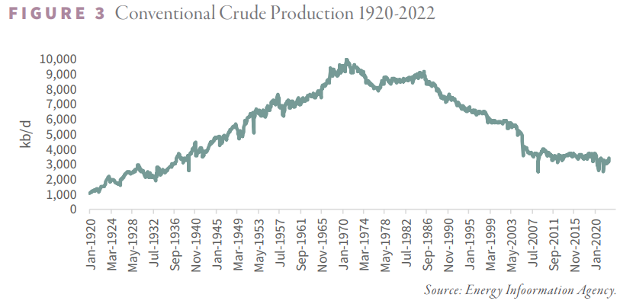

*Source: Goehring & Rozencwajg*

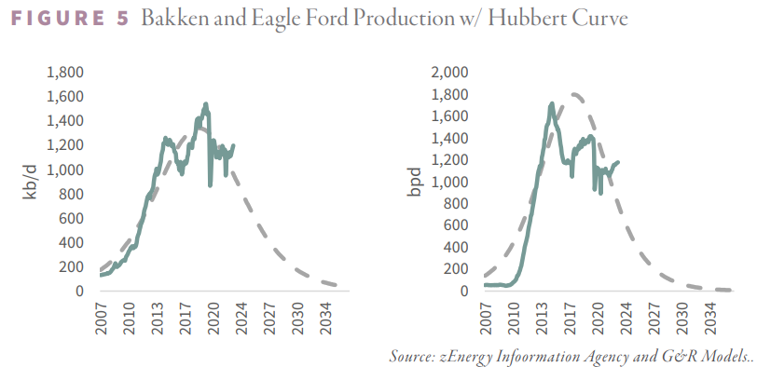

*Source: Goehring & Rozencwajg*