Cop-Out

COP28 looks set to devolve into a farce.

DOOMBERG
SEP 9, 2023

“Meetings are indispensable when you don't want to do anything.” – Ken Galbraith
In the latest edition of The Grant Williams Podcast, Christopher Joye, Chief Investment Officer and Portfolio Manager of Coolabah Capital, makes an underappreciated observation about the inflationary effects of the modern corporate organizational chart. Over the past few decades, an explosion of “mandatory” jobs that contribute little to the creation of tangible products or services—in other words, to productivity—have invaded large companies like a cancer. Joye points to the big banks, which have seen a massive increase in “compliance departments, risk departments, legal departments, government affairs departments, ESG departments, [and] human resources departments,” leading to the inevitable result that “we are producing similar products with many more people.”
Once spawned, none of these positions can really ever be eliminated, and it necessarily follows that the creation of the same increment of GDP now requires a far higher net wage expenditure. A secondary effect of so many unproductive roles is the dwindling number of qualified candidates to fill the productive ones. These observations form the basis of Joye’s view that we should expect inflation to be a tad stickier than most are modeling.
We would extend Joye’s thinking by pointing out another troubling trend in Western labor markets: that the definition of “doing work” has been blurred with “attending meetings.” As a general rule, meetings are a giant waste of time, and yet nothing makes an employee occupying an unproductive job feel more productive than being invited to one. A packed calendar is the sign of an important person, after all, and what better way to kill time until you can go home and attend your evening meetings with the team in Asia?

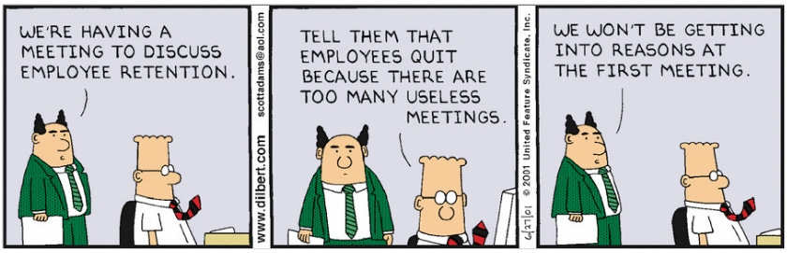

In our view, there are only two reasons to have a meeting: to make a decision or to inform others of a recent one. Neither embodiment should take more than 15 minutes. Further, the greater the number of people involved in an ill-defined meeting, the more likely it is to devolve into a jamboree of grievances. These uncontroversial statements are intuitive and universal, making the collective and continued participation in meetings all the more puzzling. As long-time readers of Doomberg will know, we view our staunch refusal to attend meetings to be a key pillar of our success.
In November, the world will descend upon the United Arab Emirates (UAE) for the 28th Conference of the Parties to the UN Framework Convention on Climate Change (COP28), a meeting expected to be attended by “over 140 heads of state, senior government leaders, over 70,000 participants and more than 5,000 media professionals.” Ostensibly, COP meetings “primarily revolve around negotiations and debates. The aim is to review progress towards the overall goal of the UNFCCC: to limit climate change.” In reality, these events are characterized by a circus-like atmosphere where the talk-do ratio approaches infinity. In the rare circumstance that anything meaningful is agreed to, such commitments are promptly ignored once the crowd disperses, subsequently serving as the foundation for countless “why are we missing our commitments?” agenda items at future annual gatherings.

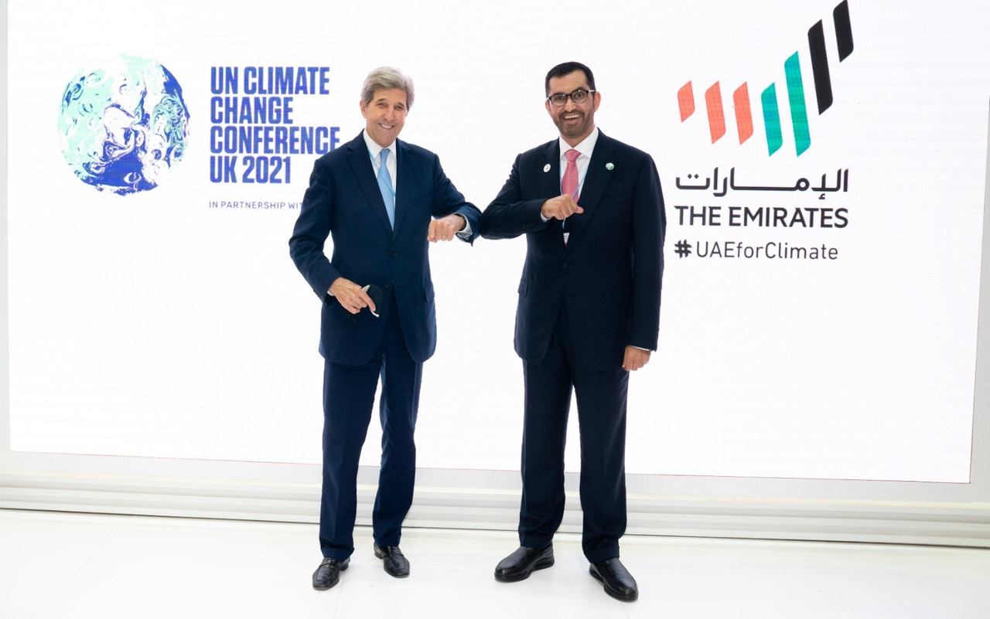

The 2023 edition of this bizarre ritual looks set to be particularly ludicrous, as a series of raging controversies has led to calls for a boycott and a general feeling of anger and disappointment among the professional environmentalist class. What is the source of this angst? Will COP28 be remembered as the moment when the ESG movement finally collapses under its own bloat? Let’s set the table for a particularly satiating feast of schadenfreude.
We begin by contextualizing what a behemoth COP summits have become. At the first COP meeting, held in Berlin in 1995, the attendee count came in at just a shade under 4,000. The main outcome of the event was an agreement to continue to meet annually (no, really, it’s true). If estimates for the 2023 congregation prove out, the crowd size will have grown 18-fold over the decades. One wonders about the carbon footprint of the entire affair. Is Zoom no longer a thing?

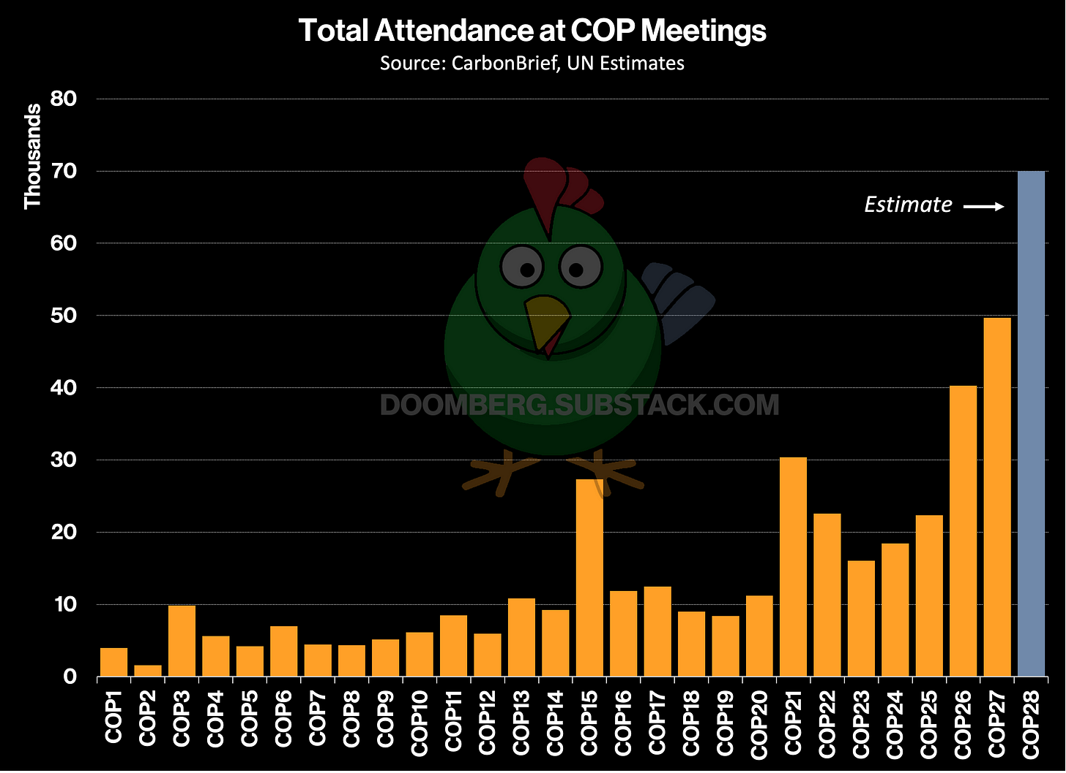

The outlook for COP28 began to look dim in January when news broke that the UAE named the CEO of its national oil company as president of the meeting. Blowback was swift (emphasis added throughout):
“The United Arab Emirates said on Thursday that the head of state oil giant Abu Dhabi National Oil Company would lead this year's COP28 climate summit, fuelling activists' worries that big industry is hijacking the global response to environmental crisis. Sultan al-Jaber, also UAE's minister of industry and technology and its climate envoy, will help shape the conference's agenda and intergovernmental negotiations to build consensus, his office said in a statement…
Global Witness called Jaber's appointment a ‘harsh blow’ to weaning the world off fossil fuels.
‘Like last year's summit, we're increasingly seeing fossil fuel interests taking control of the process and shaping it to meet their own needs,’ added Teresa Anderson, global lead of climate justice at ActionAid, in a statement.”
News of Al Jaber’s appointment led to immediate calls for a boycott of COP28 altogether, and more than 100 politicians across the US and Europe demanded that he be removed from the position ahead of the meeting. In an article published by Bloomberg in May, Manon Aubry, a member of the European Parliament and one of the signatories of the letter calling for Al Jaber’s ouster, declared, “For billions of people, the outcome of COP28 and follow-on international climate negotiations will make the difference between life and death, chaos and solidarity.”
The lives of billions of people depend on the outcome of a meeting with 70,000 attendees? Things are indeed quite bleak.

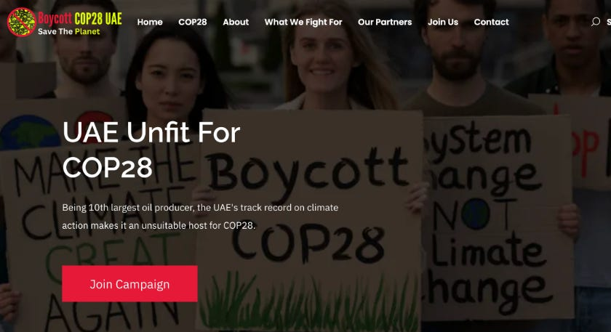

As we recently described in “It Was Never About Emissions,” many on the environmental left are in a state of absolute panic over the prospect of the successful development of carbon capture and sequestration (CCS), as this would theoretically allow for the continued use of fossil fuels without materially increasing carbon emissions. Under Al Jaber’s leadership, CCS is expected to play a prominent role in the COP28 agenda, and meanwhile, the energy industry is gearing up to spend untold billions commercializing the technology. These promising developments are why the propaganda around climate change is slowly undergoing a semantic shift from defining the problem as “emissions from fossil fuels” to “the burning of fossil fuels.”
To most of the general public, CCS would seem a good thing—a potential solution to the alleged problem that is threatening our literal extinction. Instead of welcoming this development, extreme elements of the environmental movement are pulling out all the stops to kill any discussion of the technology. Earlier this month, Reuters reported on a heated debate unfolding within the European Union as the bloc prepares its official policy position ahead of COP28. See if you can spot the absurdity:
“European Union countries are preparing to push for a global deal on phasing out fossil fuels at the United Nations COP28 climate summit which begins in November, a draft of the EU's negotiating position showed…
‘The shift towards a climate neutral economy will require the global phase-out of [unabated] fossil fuels and a peak in their consumption already in the near term,’ a draft of the EU's negotiating stance, seen by Reuters, said...
‘Unabated’ refers to fossil fuels burned without using technologies to capture the resulting CO2 emissions. The word was in brackets in the draft EU text, indicating that countries have not yet agreed on whether to include it.”

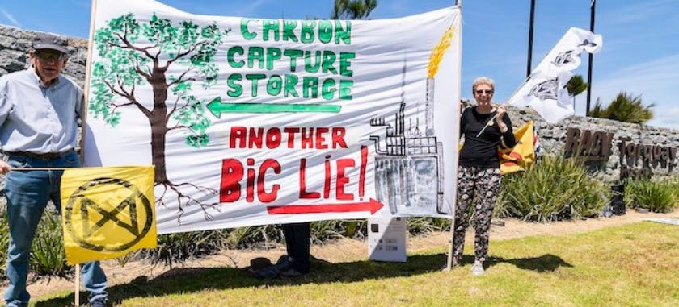
Your solutions are no good here. | Matt Hrkac/Wikimedia Commons
Although environmentalists were unsuccessful in ejecting Al Jaber, they did recently score a petty administrative victory that lays bare the totalitarian instincts of many involved. In their eyes, anybody associated with the fossil fuels industry is evil—short of eradicating these scoundrels from society, at COP28 they will be forced to identify as an inferior class:
“Fossil fuel lobbyists will have to identify themselves as such in registering for the UN Cop28 climate summit, making polluting and carbon-intensive industries more accountable at the annual talks.
The move by the UN to require anyone registering for the summit to declare their affiliation was heralded as a victory for transparency by campaigners who have been increasingly concerned at the growing presence of oil and gas lobbyists at climate talks...
Many campaigners said the change to make potential conflicts of interest more apparent should be only a first step towards excluding fossil fuel companies from the talks, or from key parts of them.”
As copious volumes of jet fuel are readied to ferry tens of thousands of COP28 delegates to and from the UAE, the stage is set for a truly historic spectacle. In our view, the meeting will almost certainly be an epic flop, producing little in the way of tangible progress. Instead, we expect a slew of headlines for all the wrong reasons, major disruptions to the prepared agenda, and unconscionable opposition to workable solutions like CCS.
Rest assured, no member of the Doomberg team will be among the 70,000. We have productive things to do.

