Molecular Tourism

On the travel habits of the world's most important commodity.
Doomberg

Sep 20 |  | ∙

READ IN APP

“The art of simplicity is a puzzle of complexity.” – Douglas Horton
If one doesn’t have reason to be entrenched in the nuances of the US energy markets, recent trends in the international trade of crude oil might seem perplexing. Despite reclaiming the mantle of the world’s largest producer of oil, the US still imports nearly 6.5 million barrels per day (bpd) of the stuff. At the same time, the country has grown to become a significant exporter of oil, crossing upwards of 5 million bpd in both 2022 and 2023. All this shuttling of barrels between borders seems rather inefficient, no? Why not just net things out domestically and import only what is needed? If only it were so easy.
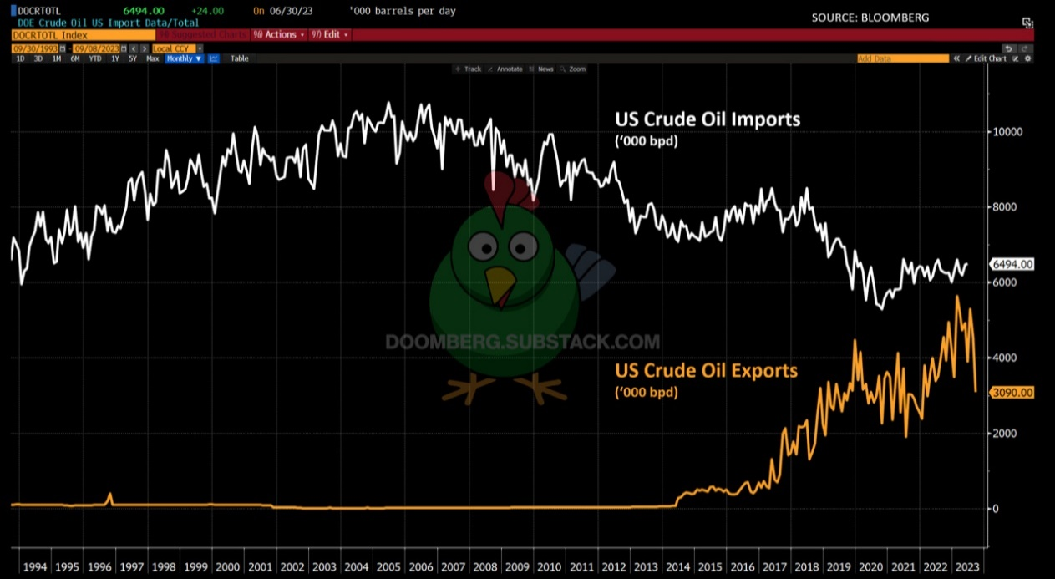
Judging by the response from those in the political class to various economic crises, they’ve ignored their fiduciary obligation to grok the fundamentals of this all-important product class. Shamelessly, superficial suggestions are trotted out from this group each time energy prices get a little frothy. Take Democratic Senator Ed Markey, who became the latest to propose banning all US exports of fossil fuels earlier this year (emphasis added throughout):
“Sen. Ed Markey (D-Mass.) introduced legislation Thursday that will reimpose a ban on U.S. fossil fuel exports, citing environmental hazards and possible impacts on domestic prices.
The measure would ‘help prioritize American consumers, protect our climate and promote environmental justice and put the United States on a path to self-sufficiency through domestic clean energy production,’ Markey said Thursday at a press conference on Capitol Hill, flanked by supporters of the bill from communities in the Rio Grande Valley and the Gulf Coast.”
The Democrats hold no monopoly on energy ignorance nor political opportunism, as Republicans were quick to prove back in January:
“The U.S. House of Representatives overwhelmingly passed a bill on Thursday to ban releases of oil from the U.S. Strategic Petroleum Reserve from being exported to China, though the measure faces an uncertain future in the Senate. The bill passed 331-97 in the House, which Republicans took narrow control of this month. All of the ‘no’ votes came from Democrats.
The issue of U.S. oil exports to China became a rallying call for Republicans last year when President Joe Biden, a Democrat, announced the sale of 180 million barrels from the SPR to tame oil prices that rose due to Russia's war on Ukraine.”
Lack of basic knowledge of how current energy markets are structured even catalyzes rare moments of bipartisanship, like when both sides of the aisle recently coalesced to express their opposition to the Biden administration’s efforts to restart oil imports from Venezuela:
“The Biden administration’s interest in regaining access to Venezuelan oil is facing stiff opposition at home over concerns it would prop up an autocratic regime that is a close ally of Russia.
The pushback comes from both Republicans and many prominent Democrats, as well as Venezuela’s U.S.-backed opposition, that recently warned officials in Washington it is a mistake to consider turning Caracas back into an energy ally without restoring democracy there first.”
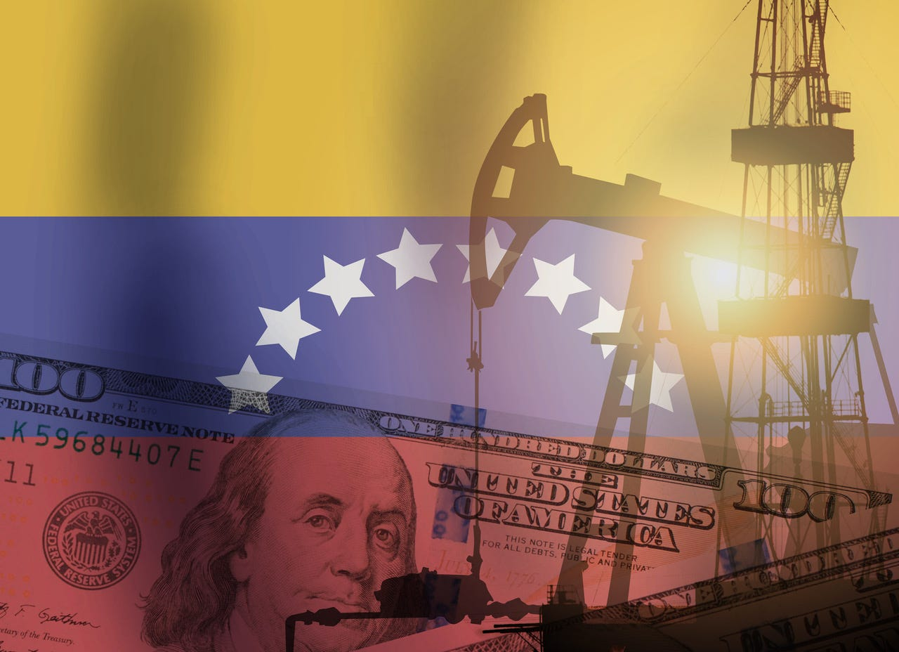
Crude compatibility | Getty
What do increasing US oil exports, oil from the Strategic Petroleum Reserve ending up in China, and efforts to reopen the oil trade with Venezuela have in common? They all make perfect sense given the current positioning of US energy assets relative to global competition. Unraveling the riddle requires an understanding that not all crude grades are created equal, each individual refinery is tantamount to a bespoke chemical plant, and the journey from crude oil to finished products like gasoline and diesel is not nearly as straightforward as many politicians believe. Let’s properly contextualize reality, recast these headlines accordingly, and build a framework for understanding which policy proposals make sense.
Let’s first clarify that there is no singular product known as “oil”—the gemish of molecules pumped up from underground is, in practical terms, unique to each well drilled. There are dozens of commercial grades of oil for which benchmark prices are quoted, and each of these is characterized by ranges of acceptable molecular composition and physical characteristics. Among the differentiating attributes are molecular weight distribution, density, viscosity, and sulfur content. Light crude oils are those with lower measurements across these dimensions, while heavy grades score higher. Sweet crude refers to low sulfur content, whereas the term sour implies a higher concentration of this unwanted impurity.
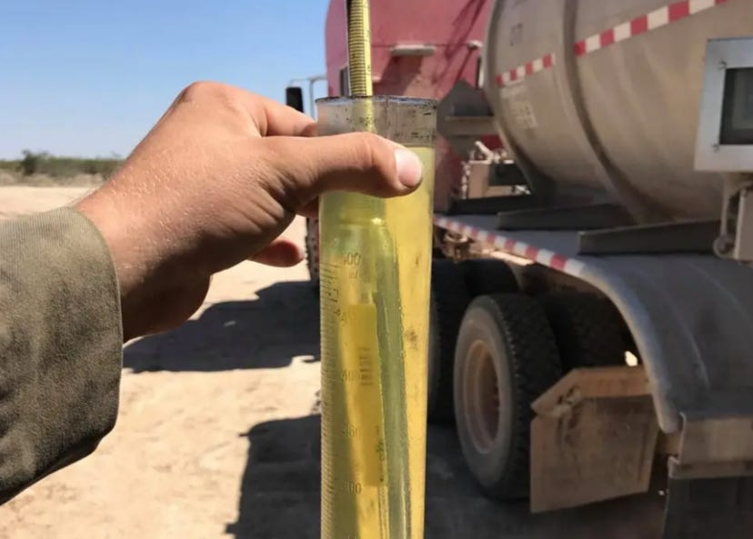
Light sweet crude from West Texas | Tony Hemen
An entire industry of midstream operators exists to blend or otherwise modify freshly pumped crude to meet refinery requirements for various grades, where they get transformed into gasoline, diesel, jet fuel, asphalt, and petrochemical inputs. Each of these downstream markets is susceptible to its own supply-demand dynamic, and signals are constantly being sent up and down the supply chain to match what is needed to that which is available.
There is also limited standardization between and among refineries. Each operation is predominately characterized by the type of crude it was originally built to handle, plus any modifications to operational flexibility its owners subsequently invested to add. At the risk of oversimplifying, the current fleet of US refineries was built to handle heavier grades of crude than the country currently produces and has been operating uncomfortably near the top of its nameplate capacity for years. It has been more than four decades since the US last built a new major refinery, and those original investments were designed to handle oil being produced domestically at that time, along with crude imported from countries like Canada, Mexico, and Venezuela.
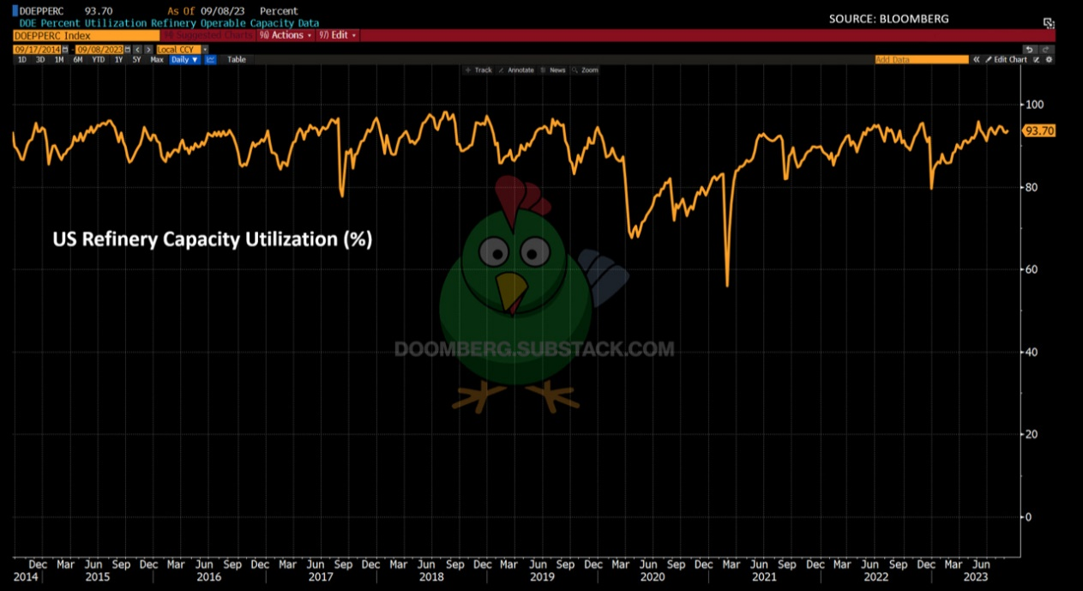
In light of these dynamics, President Obama’s decision to lift the decades-old US oil export ban in 2015 seems decidedly less controversial than it was portrayed in contemporary media reports. He was practically forced to do it—the country was swimming in oil unsuited for processing in its existing slate of refineries. While domestic facilities were already running as hard as possible, newer refineries overseas could more readily process such shipments and had the capacity to absorb them. Anytime international participants trade around existing refinery bottlenecks, the global price of diesel and gasoline stays much lower than it would otherwise be.
Now ponder the economically destructive impact Markey’s blanket fossil fuel export ban would deliver. The US refinery network exists in its current form in large part because of the difficulty involved in obtaining permits for new facilities or major upgrades. Having been hamstrung by environmental opposition to expansion or modification efforts, the industry has been forced to optimize across international borders. Banning the free flow of petroleum products now would wreak havoc in the global gasoline, diesel, and jet fuel markets. Skyrocketing prices would undoubtedly follow.

Senator Markey’s Dukakis moment | Getty
It is similarly unsurprising to learn that oil released from the Strategic Petroleum Reserve ended up in China. President Biden’s objective was to lower the “price at the pump” ahead of the midterm elections, and US refineries were already well supplied. China has a huge untapped refining capacity, and even though it tightly controls its exports of refined fuels, every gallon it produces domestically is one less it has to procure from the global markets, which in turn reduces prices for US consumers. The motivation to wield the SPR for nakedly political purposes is abysmal, but that some of these molecules found their way to China is a result of refinery availability.
Finally, we turn to US efforts to reopen the oil trade with Venezuela. As should be clear by now, the motivation to do so is driven by the suitability of Venezuelan heavy crude for US refineries. To the extent that those refineries are using suboptimal crude inputs today, the arrival of new supply from Venezuela could make blending with domestic oil more efficient or even free those cargoes for export, thereby enhancing global refining efficiency. Make no mistake, in pursuing this path, the Biden administration lays bare the folly of having killed the Keystone Pipeline project that was meant to facilitate the transportation of Canadian heavy crude from Alberta to these same refineries along the US Gulf Coast.
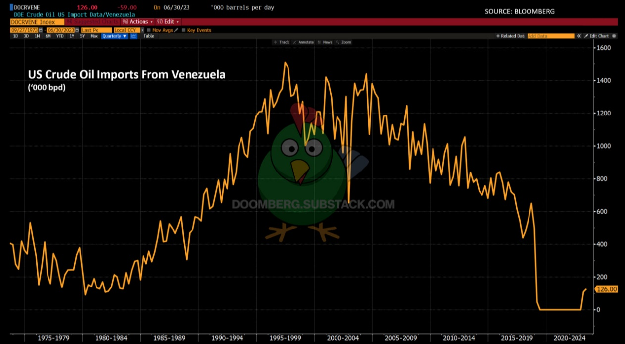
Taken together, diversity of oil composition, ever-changing market needs, and limited processing capabilities at the refinery level combine to generate an economic ecosystem that is difficult for industry outsiders to fully grasp. It is nonetheless fair to expect policymakers and central planners to do their darnedest to try before promoting their ham-handed proposals.
If the objective is cheap and stable access to refined products (and maybe it isn’t), then supporting new refining capacity, extending the flexibility of the existing fleet, and building out the infrastructure needed to better connect various crude grades to the processors that can handle them should be anchors of our policy framework. Everything else is just political grandstanding.

