

Windbaggery

The wind energy sector's days are numbered.
Doomberg

READ IN APP

“Reason, I sacrifice you to the evening breeze.” – Aimé Césaire
To be an effective podcast guest requires a few basic tactics. First, it is important to let the host get their full question asked before beginning to answer yourself. In normal conversation, it is not uncommon to understand where a friend is going and to get there before they do, but in a podcast setting it can be off-putting. It is also advisable to directly address the host’s questions in a concise manner and to mix in a few memorable phrases that listeners can work into their own discourse. Driving home a key communication objective with a catchy turn of phrase—a verbal meme, if you will—can make the difference between being remembered or forgotten.
One phrase that we coined and have popularized on various podcast appearances is “In the battle between physics and platitudes, physics is undefeated.” It is a polite way of articulating that the hard realities of life must eventually be confronted, and no amount of pompous speech, deceptive statistics, or outright fabrications can overcome the laws of physics. It might take many years, involve billions in misallocated money, and cause significant social and political upheaval, but one simply cannot wish away the fundamental constraints of the universe. The global energy strategy is no exception.

Captain Platitude, reporting for duty | Getty
Perhaps no sector is more guilty of leaning on platitudes than the wind industry. Through dishonest manipulation of cost estimates and a relentless campaign of propaganda, proponents of wind energy have convinced countless politicians to support a technology that disrupts the smooth operation of electricity grids and is utterly dependent on the intermittency of the weather. Anybody with a passing knowledge of energy fundamentals knows this simply can’t be sustainable, as we explained back in February (emphasis added throughout):
“…the fundamental challenge plaguing wind technology: low energy density. Wind is dispersed and to harvest economically significant amounts of energy from it with any semblance of efficiency requires huge plastic composite blades that are designed to be both lightweight and exceptionally strong. The forces and material science challenges involved are substantial. Offshore wind blades now exceed 100 meters in length, and their tip speeds can surpass an incredible 200 miles per hour. The blades convert kinetic energy into rotational energy, which is then usually fed into a gearbox, which increases the rotational rotor speed. A generator is then used to produce electricity. Electrical, mechanical, and blade failures are common and expensive, as are the myriad ongoing servicing activities needed to maintain smooth operation. Confronting these fundamental limits of physics is challenging.”
During our July Doom Zoom presentation—Doom Scrolling: Searching the Globe for Things to Worry About—we made the case that the wind sector might be teetering on the verge of collapse. We argued that the never-ending pursuit of longer blade lengths would be the industry’s undoing, that the resulting balance-of-system stresses were being wholly underestimated, and that the existing fleet of turbines in the field are stationary point-sources of future liability for those who installed them. We repeated our claim that levelized cost of electricity (LCOE) estimates were tantamount to fraud, and that the veil would soon be lifted, causing significant disruption to the entire wind value chain.
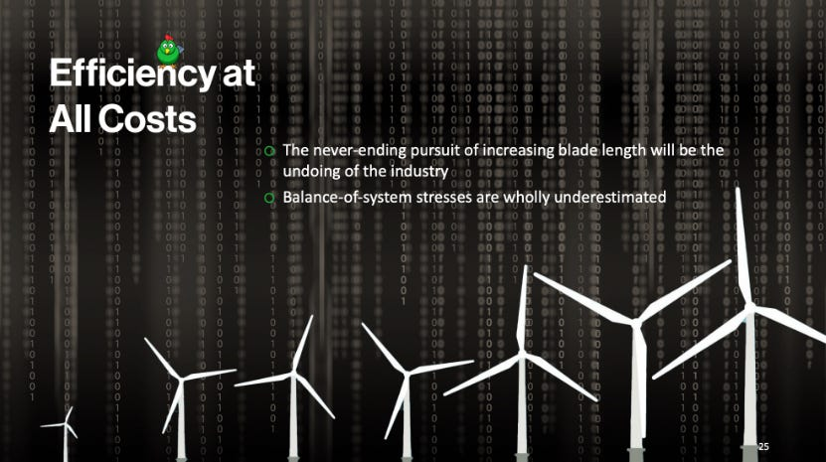
Slide 25 | July’s Doom Zoom presentation
In the intervening weeks, the pace and severity of news articles detailing the wind industry’s persistent struggles have surprised even us. At a time when the Biden administration is pushing for massive new installations of both onshore and offshore wind turbines, the sector is recoiling from one disaster after another, calling into significant doubt the wisdom of throwing good money after bad. Are we finally nearing the crossroads? Will the realities of physics conclusively reassert themselves? Let’s stick a finger in the wind and find out.
This might come as a surprise to some, but projects that require an enormous amount of concrete, steel, high-performance plastic resins, fiberglass or carbon fiber reinforcement materials, high-end magnets derived from rare earth metals, designer lubricants, and labor are susceptible to inflation dynamics and particularly sensitive to the price of fossil fuels. This is further pronounced if all this effort is directed toward harvesting ultra-low-density energy sources like wind. Even the Washington Post was forced to begrudgingly admit as much last week:
“Renewables have also been hurt by broader inflationary dynamics. The cost of raw materials and construction labor has gone up. And to an extent, the industry has been hurt by its very growth, which is not restricted to one country or region but is global.
The current squeeze is particularly acute in the field of offshore wind projects, which are extremely important to the energy future of the northeastern US. These are places with progressive politicians who want to decarbonize, but they’re not as sunny as California and they don’t have the wide open spaces of the plains to deploy utility-scale onshore wind.”
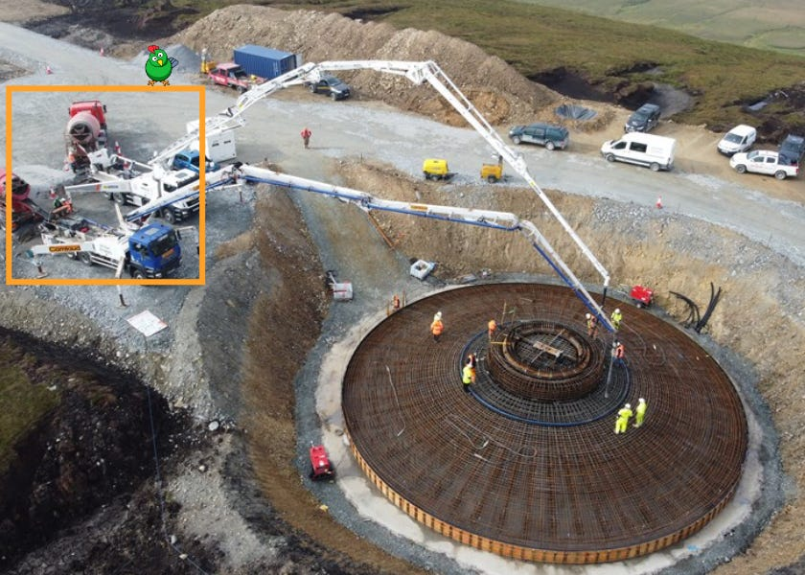
That’s a lot of concrete | Viking Energy
While the wind sector has certainly grown—and this has crimped the supply of certain materials—the manner in which it expanded has exacerbated the problem. The industry lacks much in the way of standardization, and many developers have agreed to localize various aspects of their supply chains across innumerable states, provinces, and cities to win political backing for new projects. As a consequence, benefits from economies of scale have been difficult to realize.
These ominous currents have put the developers who already inked fixed-rate contracts with utilities in a spot of bother, and many are seeking a do-over. In some instances, companies are walking away from their commitments, preferring to pay substantial breakup fees over embarking on money-losing mega-projects. Here’s just one example from New York, where the sobering effects of reality are finding their way into the political conversation:
“Multiple offshore wind projects that are not even built yet have asked the state’s Public Service Commission (PSC) to renegotiate their strike prices—the amount they will be paid per megawatt hour (MWh) of electricity produced. (A megawatt hour is roughly enough electricity to power 750 homes for one hour.)
Ørsted and Eversource have asked for a 27 percent increase for their Sunrise Wind project, which would raise their strike-price from around $110 to nearly $140 per MWh. And the joint venture of Equinor and BP has asked for increases on all three of the projects it is developing. For Empire Wind 1, they want a 35 percent increase that would raise its strike-price from $118 to almost $160, for Empire Wind 2 a 66 percent increase that would bring its strike-price from $107.50 to almost $178, and for Beacon Wind a 62 percent increase to lift its strike-price from $118 to over $190.”
With an inability to generate a profit at reasonable electricity prices, it is unsurprising that planned future projects are suddenly going “no bid”:
“No new offshore wind project contracts have been bought by developers at a key government auction, dealing a blow to the UK’s renewable power strategy. Results showed no bids for new offshore wind farms, but there were deals for solar, tidal and onshore wind projects.
Firms have argued the price set for electricity generated was too low to make offshore wind projects viable. The government said a ‘global rise’ in inflation impacting supply chains had ‘presented challenges for projects.’”
All this industry backpedaling comes on the heels of long-held claims that wind energy is the cheapest form of electricity available on the market. This lie is based on faulty LCOE calculations, a methodology of cost estimating that is designed to make renewable energy projects look better at the expense of traditional power sources like natural gas, coal, and nuclear. In fact, LCOE “is so spectacularly contrary to reality that it doesn’t nearly do it justice to call it just a ‘lie.’” In the face of the events of the past few months, anybody who continues to push this metric should have their intentions questioned.
If cost pressure was the only issue facing the wind industry, things might not be so dire. Inflationary pulses come and go, after all, and governments in the West aren’t usually afraid to throw money at problems of their own making. But there’s a giant scandal brewing in the offshore wind industry, one that seems to involve an overt coverup on the part of scientists at the US National Oceanic and Atmospheric Administration. Dozens of endangered whales are dying all along the US East Coast, and the wind industry is almost certainly to blame. Michael Schellenberger and the team at Public have done an incredible job exposing this troubling series of events:
“The increase in whale, dolphin, and other cetacean deaths off the East Coast of the United States since 2016 is not due to the construction of large industrial wind turbines, U.S. government officials say. Their scientists have done the research, they say, to prove that whatever is killing the whales is completely unrelated to the wind industry.
But now, a new documentary, ‘Thrown To The Wind,’ by Director and Producer Jonah Markowitz, proves that the US government officials have been lying. The full film, which is at the bottom of this article, documents surprisingly loud, high-decibel sonar emitted by wind industry vessels when measured with state-of-the-art hydrophones. And it shows that the wind industry’s increased boat traffic is correlated directly with specific whale deaths.”
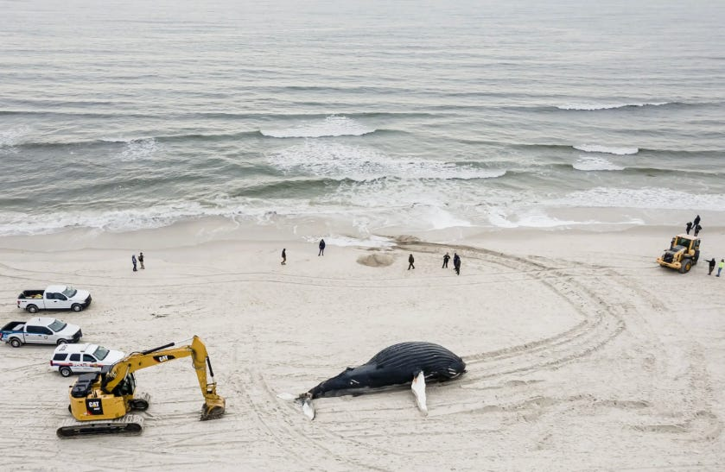
The mystery that wasn’t | Justin Lane/EPA
Adding insult to their injury, there’s yet another nagging issue plaguing the wind energy sector: turbine blades are practically impossible to recycle, and most will remain buried in landfills, effectively forever. The very toughness that is necessarily designed into these high-performance composites is what makes them extremely challenging to recycle, and despite claims to the contrary, there aren’t yet any viable processes to handle the avalanche of end-of-life blades coming in the years ahead. Amazingly, the industry has made the problem significantly worse in its reach for yet more government handouts. We turn to an explosive report in Texas Monthly for the shocking details:
“The Sweetwater piles are also at least partly the indirect result of a rule clarification the Internal Revenue Service issued in 2016. Before then, a wind farm could collect valuable federal tax credits for only its first ten years of operation. But the IRS determined that it would restart the clock on the credits if a wind farm ‘repowered’ its turbines—replacing most of their equipment with newer parts. So, despite the expected two-decade lifespan for turbine blades, wind farms across Texas and other states began replacing many that remained in good shape years early.”
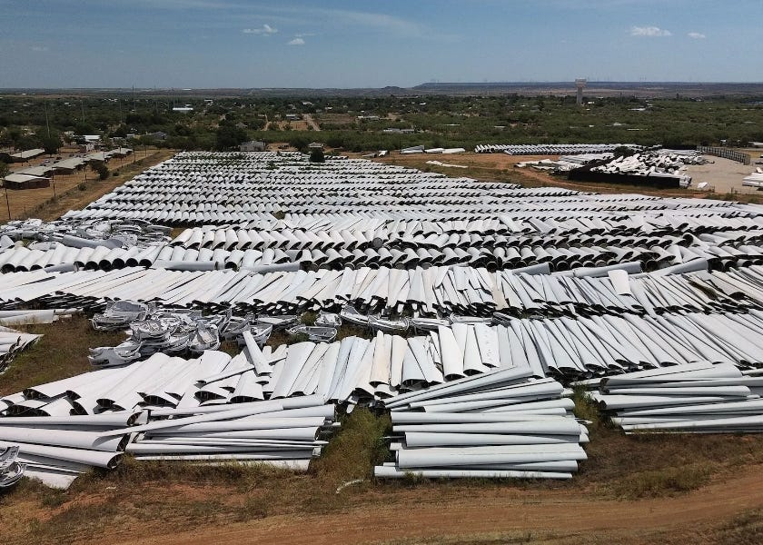
Blade yard | Eli Rosen/Yucca Films
As we reflect on the current mess that is the wind industry, we can’t help but ponder how future historians will marvel at the sheer lunacy of it all. As evidence of the sector’s ongoing implosion continues to mount, efforts to further impose this failed technology upon our society are only accelerated. The Biden administration is still insisting that there will be 30 gigawatts of offshore wind capacity installed between now and 2030, actively pretending that the real world simply does not exist. Spinning turbine blades now stand as the perfect metaphor for the circular nature of our broken energy policy.
We might just have to add that last line to our podcast repertoire.

