Can Happiness Be Taught?

*Bolstered by Oprah, a Harvard Business School professor thinks you should run your inner self like a company.*

**By**[**Anthony Lane**](https://www.newyorker.com/contributors/anthony-lane)

*The New Yorker* October 16, 2023

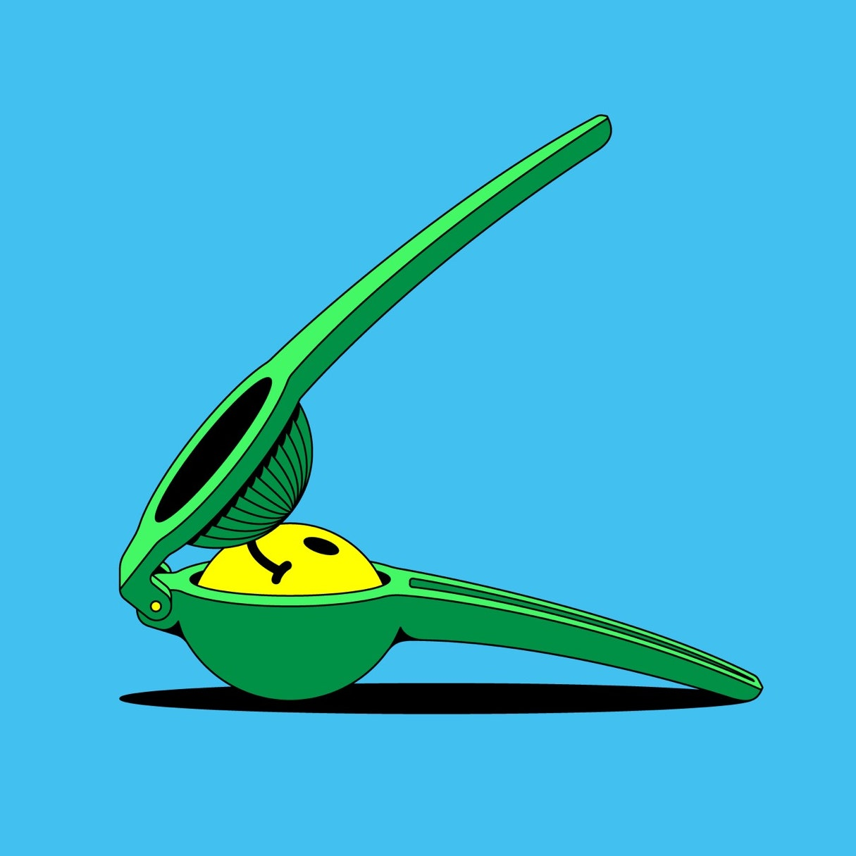

In the publishing world, the care and maintenance of the self is no longer a branch of the social sciences or an offshoot of popular psychology. Personhood, like religion and politics, is a business.Illustration by Till Lauer

Staring into the mirror, on a Tuesday morning, you decide that your self needs all the help it can get. But where to turn? You were reading James Clear’s “[Atomic Habits: An Easy & Proven Way to Build Good Habits & Break Bad Ones](https://www.amazon.com/Atomic-Habits-Proven-Build-Break/dp/0735211299/?ots=1&tag=thneyo0f-20&linkCode=w50)” and doing well until you spilled half a bottle of Knob Creek over the last sixty pages. Now you’ll never know how it ends. You tried listening to David Goggins’s “[Can’t Hurt Me: Master Your Mind and Defy the Odds](https://www.amazon.com/Cant-Hurt-Me-Master-Your/dp/1544512287?ots=1&tag=thneyo0f-20&linkCode=w50),” on Audible, in your car, but so thrilling was Goggins’s prose style that you stomped on the gas and rear-ended a Tesla. Do not despair, though. Succor is at hand. Roosting on Amazon’s best-seller list is “[Build the Life You Want: The Art and Science of Getting Happier](https://www.amazon.com/Build-Life-You-Want-Science/dp/0593545400?ots=1&tag=thneyo0f-20&linkCode=w50),” by Arthur C. Brooks and Oprah Winfrey (Portfolio).

At this point, your conscience rebels. By buying a book on Amazon, you tell yourself, you will be directly funding a new angora lining for [Jeff Bezos](https://www.newyorker.com/tag/jeff-bezos)’s monogrammed slippers in the master bedroom of his private yacht—not the main one but the backup vessel currently moored off Patmos. Quivering with righteousness, you close your laptop and stride to your nearest bookstore, only to bump into a dilemma: whereabouts in the store, exactly, can “Build the Life You Want” be found?

It is not an easy volume to place. You’d assume that it belongs on the self-help table. Yet the title suggests home improvement or even civil engineering, and so ardently does Brooks insist on the “four big happiness pillars”—family, friendship, work, and faith—that readers of a nervous disposition may choose to wear a hard hat. On the other hand, Brooks is a professor of management practice at Harvard Business School, so he would slot into the business section with ease. Given that, as he says, “the macronutrients of happiness are enjoyment, satisfaction, and purpose,” there’s an equally strong case for the cookery shelf. Or how about philosophy? Anyone who cites Marcus Aurelius, Thomas Aquinas, Kant, Mick Jagger, Epicurus, *and* Epictetus, as Brooks does, would be totally stoked to hang out in such lofty company. No one, of course, is loftier than his co-author, and, if your bookstore is furnished with an Oprah wing, that is where the book must be displayed.

When two writers join forces, it can be tricky to sort out who did what. Not in this case. Brooks is the principal player, and Oprah is his guest star. Only four times does she enter the action to offer “A Note from Oprah,” and the four notes, added together, take up less than fourteen pages in a book that is more than two hundred and forty pages long. What does she bring, then, apart from the humongous commercial clout of her blessing? Well, she reveals that “The Oprah Winfrey Show” was “always at heart a classroom. I was curious about so many things, from the intricacies of the digestive system to the meaning of life.” (Had she been French, of course, those two items would have been the same.) Near the start of the book, ever alert to her audience, she scrunches what she considers Brooks’s most valuable lesson into “words you should tape to your refrigerator,” and, for extra clarity, accelerates into italics: “*Your emotions are only signals. And you get to decide how you’ll respond to them*.” One more scrunch, and Oprah has the mantra she wants: “*Feel the feel, then take the wheel*.”

What’s interesting about this advice is that far behind it, dimly discernible, is another speeding vehicle, fuelled by allegorical intent: the chariot drawn by a pair of winged horses and deployed by Socrates, in Plato’s Phaedrus, to illustrate the motions of the soul. One horse, representing our nobler instincts, is “upright in frame and well jointed,” whereas the other is a hell of a nag, “a crooked great jumble of limbs,” forever dragging us down toward the lower desires. All in all, chariot-driving is what Socrates calls “a painfully difficult business,” as is being alive, and the task that Brooks and Oprah set for themselves, in their affable and optimistic fashion, is the age-old one of turning us into better charioteers. Our feelings urge us this way and that, and we should learn when to yank on the reins and when—steady now—to try a touch of the whip.

Whether Brooks has an actual chariot, Massachusetts traffic laws being what they are, I cannot say. Heaven knows what Oprah keeps in her stables. But it’s charming to note the confidence with which Brooks, for one, presents his credentials as a successful whipster. He experimented on his own routines and began teaching a class on happiness at Harvard, not to mention composing a regular column for *The* *Atlantic* on the same topic. By his account, “I saw more and more progress in my life.” Onward and upward he flew:

In the years since I made this life change, my own well-being has risen *a lot*. People notice and remark that I smile more, and I look like I’m having more fun in my work. My relationships are better than they were.

We’re so happy that you’re happy, Professor! Far be it from me to point out that such protestations of improvement, sincere as they are, have a whiff of the travelling salesman—you know, the guy who puts a foot in the door and says, “Believe me, Ma’am, I’ve been using this very same vacuum cleaner in my own home for three months now, and the effect of that heightened suck power is just tremendous. My dust has all but vanished. My carpets look brand new.” To anyone browsing “Build the Life You Want” and books of a similar ilk, it soon becomes clear that the care and maintenance of the self is no longer a branch of the social sciences, if it ever was, or an offshoot of popular psychology. Restructuring your inward being, and increasing its turnover, is now akin to running a company. Personhood, like religion and politics, is a business.

It doesn’t take long for Brooks to get the business going. He proudly inducts us into the thrill of the Positive and Negative Affect Schedule, or panas, which gauges “your natural happy-unhappy mix.” This gives us a list of twenty emotions, such as “6. Guilty 7. Scared 8. Hostile 9. Enthusiastic.” (A perfect guide, as it happens, to the average day of a movie critic.) You note down how keenly you feel the feel, as Oprah would say, grading each emotion for intensity, then calculate your final score. This, in turn, shows where you belong on a pretty diagram, reproduced on page 16 of “Build the Life You Want,” that divides *Homo sapiens* cleanly into four basic types: Cheerleader, Mad Scientist, Judge, and Poet. Really? Imagine asking J. Robert Oppenheimer to nominate which one of those he thought he was. He would have exploded.

You’ve got to love the panas test. It means almost nothing, yet it gives you the bracing impression that you’re down on the factory floor, tinkering away on the unique machine that is you. It is, to use Oprah’s splendidly honest term, “science-y,” right down to the vague, if benign, laboratory conditions that Brooks dictates. “To take the test, find a time when you feel relatively neutral about life—say, right after lunch,” he writes. But what sort of lunch? If it’s three o’clock in the afternoon and you’re lingering over coffee and gazing out across the Bay of Naples, you will give thanks for the wonders of creation. Conversely, if you just blew seven dollars and twenty-nine cents on a Subway footlong, you will hold your fellow-humans in contempt and assume, naturally, that the world is an overcooked meatball hung in a meaningless void.

Undaunted, Brooks forges onward, and makes further encouraging claims about his methods. Eager to prove that even negative feelings, if shrewdly handled, can have a positive outcome, he ventures into the realms of the book-y. He even gets arts-y on our ass. Quoting a line from Keats’s letters—“Do you not see how necessary a World of Pains and troubles is to school an Intelligence and make it a soul?”—Brooks adds, “Scientists have found that Keats was right.” If only all literary criticism could be as brisk as that. Moreover, according to a study cited by Brooks, “The research found that among great composers like Beethoven, a 37 percent increase in sadness led to, on average, one extra major composition.” That sentence makes me twenty-four per cent less sad, and eighty-one per cent more inclined to giggle, than anything I have read this year.

Brooks is scarcely the first to propose that our happiness, and its opposite, can and should be quantified as precisely as barometric pressure. In “[An Introduction to the Principles of Morals and Legislation](https://www.amazon.com/Introduction-Principles-Legislation-Philosophical-Classics/dp/0486454525?ots=1&tag=thneyo0f-20&linkCode=w50)” (published, by a murky coincidence, in the year of the French Revolution), the philosopher Jeremy Bentham, clinging fast to his utilitarian creed, devised what came to be known as the felicific calculus. In theory, this allowed you to evaluate any given act in terms of its ensuing pain or pleasure, which could be graded according to various criteria: intensity, duration, certainty, propinquity, fecundity, purity, and extent. In practice, the last of these—which sounds tame, and which refers to the number of people who will be affected by the act—is probably the most morally ticklish, as any secondhand smoker can confirm.

With a couple of centuries’ worth of medical probing behind him, Brooks can boldly go where Bentham was unable to go before and lead us to the particular neighborhoods where pain and pleasure hang out. “Build the Life You Want” plays peekaboo with the reader, affording sneaky little glimpses of the hypothalamus, the insula, and the adrenal glands. Are we genuinely expected to master this material, though, or is it designed purely to reassure us that we are in safe hands? When Brooks, analyzing our reaction to fear, writes, “Your periaqueductal gray, which also receives a note from your amygdala, tells your body to move,” the prosaic image of the note—plucked from our everyday lives—is what sticks and stays. To be told that our internal mail system is like that of a well-run office comes as quite a relief. Then, there is metacognition, a buzzword that hums throughout the book and entails “experiencing your emotions consciously” and “refusing to be controlled by them.” Brooks expounds:

You might compare it to the process of taking petroleum from the well (your limbic system) to a gas refinery (the prefrontal cortex), where it can be made into something you can use purposively.

It’s not the greenest analogy I’ve ever seen, but, hey, it does the job. Such is the tactic by which Brooks and the other sovereigns of self-help, with considerable skill and a pinch of cunning, advance their cause. They borrow difficult concepts from the realms of neurology and behavioral science, among others, and couch them in a patois that we recognize. Few of us may have read a paper from a 2013 issue of *Depression and Anxiety*—think *The World of Interiors* without the cashmere throws—titled “Reports of Drinking to Self-Medicate Anxiety Symptoms: Longitudinal Assessment for Subgroups of Individuals with Alcohol Dependence.” But Brooks *has* read it, and has filtered its findings into his thoughts on addiction. (The paper, I couldn’t help noticing, had eleven authors. I trust that they ganged up and got pie-eyed on Zombies to celebrate publication.)

Homework, though, is not the nub of Brooks’s enterprise. The nub is that he’s required, by the panic-stricken temper of the times, to insist that we can and must get better at being who we are. It could be argued that so positive an outlook is, and always has been, a by-product of any inquiry into the conduct of our earthly existence, although a self-help book by Schopenhauer would, perhaps, flummox more readers than it would assist. On the other hand, if anything yokes together the philosophers cited by Brooks, it is the willingness, or the unavoidable compulsion, to worry away at one moral conundrum after the next, like dogs unearthing a bone to have another go at the marrow. You could spend a lifetime, say, stubbornly chewing on what Aristotle, in the Ethics, means by *eudaemonia*. “Happiness” alone won’t suffice. Aristotle himself, treading carefully, writes, “We have practically defined happiness as a sort of living and faring well.” I am partial to the modesty of “human flourishing.” Others prefer something like “the activity of a rational soul in accordance with virtue”—a daunting ideal that held sway for twenty-five hundred years, until it was roundly rebuffed by the creators of “Jackass.”

Whether there is still a place for the steady intellectual grind is open to question. Readers and publishers alike are worried by all that worrying. Understandably, their quest is for books that promise results, primed to beef up one’s *eudaemonia* levels like a shot of Vitamin B12. Hence the speed with which the mood of Brooks’s book, grammatical and tonal, is set within the title: not “How to Build” but “Build.” Thereafter, the imperative reigns supreme. “Start by working on your toughness.” No sweat. “Take your grand vision of improvement and humble ambition to be part of it in a specific way and execute accordingly.” Check. “Rebel against your shame.” Done. “Widen your conflict-resolution repertoire.” Ka-pow! “Treat your walks, prayer time, and gym sessions as if they were meetings with the president.” Which President? “Journal your experiences and feelings over the course of the day.” Since when did “journal” turn into a transitive verb? “Dig into the extensive and growing technology and literature on mindfulness.” Sorry, I was miles away, what? Above all, “Remember: *You are your own CEO*.” Holy moly. Do I have to wear a suit to brush my teeth? Is my dog a shareholder? Were last year’s migraines tax-deductible? Can I be fired by me?

The problem with imperatives is that the more frequent they become, or the more impassioned, the harder it is to obey them and to predict what the fallout from their implementation might be. When Judy Garland, in a tux and black tights, belted out “Get Happy” in “Summer Stock” (1950), you bowed to her command, even if you knew that her life off camera lay in ruins. When she sang the song thirteen years later, on TV, it was intertwined with “Happy Days Are Here Again,” sung by Barbra Streisand, who sat beside her: a rending mashup of two American anthems, delivered at a slow and stricken tempo, as if to acknowledge that the getting of happiness exacted too high a price. And, once it was got, then what?

You hear that fear again in the voice of [Cary Grant](https://www.newyorker.com/magazine/1975/07/14/cary-grant-profile-pauline-kael) in “Mr. Blandings Builds His Dream House” (1948). He plays an advertising man, hitherto squashed into a small New York apartment with his family, who buys a wreck in Connecticut, has it torn down, puts up a new place, and gets pushed to the brink. “Anybody who builds a house today is crazy. The minute you start, they put you on the list. The All-American Sucker list. You start out to build a home and you wind up in the poorhouse,” he cries. “What about the kids who just got married and want a home of their own? It’s a conspiracy, I tell you, a conspiracy against every boy and girl who were ever in love.” The movie is a light comedy, but, this being Grant, the shadow of desperation is never far away, and what maddens Mr. Blandings is not just the practical chaos and the financial waste but the expense of spirit. He has been sold on his own dream.

I thought of Mr. Blandings often as I plowed through “Build the Life You Want.” Brooks radiates decency and good will; if you yearn to do up your life, like somebody who knocks down a wall and repaints the kitchen, he will lend you the tools. There is almost nothing that he will not undertake to fix. He has a stirring chapter on friendship, for which he has a proper Aristotelian reverence. (Even Bentham, no party animal, recommended “the pleasures of amity.”) So kindly is his disposition, indeed, that he has faith in the gentle resolving of ideological differences. The trick, apparently, is to reserve judgment: “You will find yourself not weighing in on political debates and giving fewer opinions; this will keep you calmer and in a greater state of inner peace.” It’s wonderful to reflect on the millions of people who will heed that advice and maintain a monastic silence as we enter an election year.

Here and there, however, as you browse the book, you catch murmurs of disquiet. They tend to arise in casual comments, such as “Taking negativity personally can lead to rumination.” Heaven forfend! A ruminator on the loose! At other times, a plain recitation of statistics can freak you out, as when Brooks adduces an academic study from 2007:

The researchers then examined a data set from another study that rated incoming college freshmen’s “cheerfulness” and tracked their income nearly two decades later. They found that the most cheerful in 1976 were not the highest earners in 1995; that distinction once again went to the second-highest group, which rated their cheerfulness as “above average” but not in the highest 10 percent.

Where to begin with this? With the assumption that cheerfulness is a measurable quality and that, more to the point, a person is guaranteed to be the most reliable assessor of her or his own cheer? Or with the uncontested idea that a rising income conveys you ever closer to the summum bonum? It might have been pertinent, at this juncture, if Brooks had directed inquisitive readers to the Easterlin paradox—that is, to a controversial paper of 1974, “Does Economic Growth Improve the Human Lot? Some Empirical Evidence,” by the economist Richard A. Easterlin. The link between earnings and contentment, Easterlin claimed, was not as firm as might be expected, especially when one compared a variation in earnings inside a single country with a variation *between* two separate countries. The fun part came in a chart that laid out the “Personal Happiness Rating” of thirteen nations, as recorded in the late fifties and early sixties. The lucky winners were the United States and Cuba.

How most of us would rate our personal happiness these days, even without the Bay of Pigs to look forward to, is not something that Arthur C. Brooks and Oprah Winfrey presume to plot on a graph. I suspect, however, that in their view most of us are weltering in a woe of our own devising, and that, unlike Beethoven, we can’t even get a decent symphony out of it. Hence Brooks’s most provoking sentence of all, which is tucked away in parentheses, lest it disturb our equanimity. “(Unhappy people make great consumers),” he writes. And there we arrive at the heart of the matter. “Build the Life You Want” is the pure product of a liberal capitalist democracy: First World fretting, one might say, politely disguised as universal wisdom. It both springs from and speaks to an unmistakable patch of the planet, and, with the aid of muscular marketing and the imprimatur of Oprah, it will be ingested by those whose dolor, to their bewilderment, has been aggravated rather than soothed by mass consumption. “Turn off self-view on Zoom. Don’t take any selfies,” we read, in this rousing hymn to self-help. Round and round we go. ♦

Published in the print edition of the [October 23, 2023](https://www.newyorker.com/magazine/2023/10/23), issue, with the headline “Get Happy.”

[*Anthony Lane*](https://www.newyorker.com/contributors/anthony-lane)*has been a film critic for The New Yorker since 1993. He is the author of “*[*Nobody’s Perfect*](https://www.amazon.com/dp/0375714340/?ots=1&tag=thneyo0f-20)*.”*