Meat in the Middle

When it comes to the carbon counters, your diet is on their menu.
DOOMBERG
DEC 2, 2023

“Barbecue may not be the road to world peace, but it's a start.” – Anthony Bourdain
This week in the United Arab Emirates, the 28th session of the Conference of the Parties (COP28) to the UN Framework Convention on Climate Change begins. Always a spectacle, this year’s edition of the carbon pilgrimage looks set to be an epic circus, with all manner of extremists colliding against the grating challenge of lowering global carbon emissions. We have long held the view that the progressive environmental left is asking for the impossible—a global populace voluntarily lowering its living standards to abate intangible risks that might materialize far into the future—and that pressing for such degradation is the ultimate political dead end. The world is simply going to roll the dice on climate change and manage the consequences accordingly.
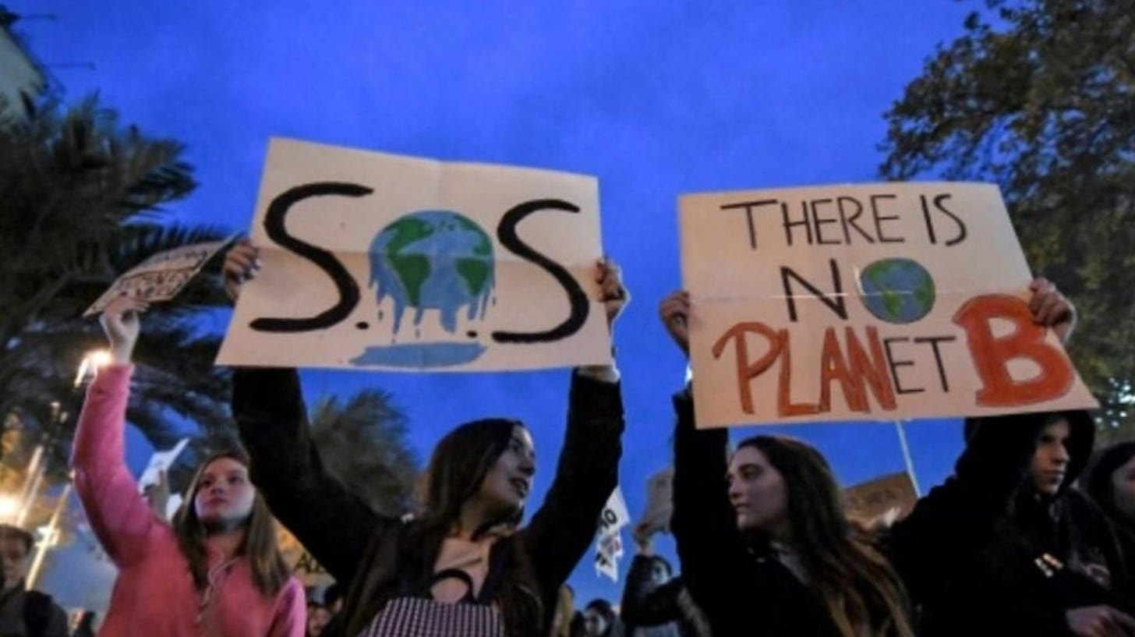
TFW you wonder if this is really the best use of your time | AFP
Uncertainty of outcome notwithstanding, if one truly believes the world is heading for a cataclysm, it is easy to be convinced that extremism is morally justified. From there, it is a short walk from balking at resistance to your views to demanding blanket power to enforce them. For a glaring example of such a setup developing, we turn to an article in Bloomberg that published last week (emphasis added throughout):
“The world’s most-developed nations will be told to curb their excessive appetite for meat as part of the first comprehensive plan to bring the global agrifood industry into line with the Paris climate agreement…
The guidance on meat is intended to send a clear message to governments. But politicians in richer nations typically shy away from policies aimed at influencing consumer behavior, especially where it involves cutting consumption of everyday items.
‘Livestock is politically sensitive, but we need to deal with sensitive issues to solve the problem,’ said Dhanush Dinesh, the founder of Clim-Eat, which works to accelerate climate action in food systems. ‘If we don’t tackle the livestock problem, we are not going to solve climate change. The key problem is overconsumption.’”
Being previously unaware of “Clim-Eat,” we headed over to its website to see what we could learn about Mr. Dinesh, whose official title is “Chief Climate Catalyst.” The only thing surprising about his biography is that it is written in the third person:
“Meet Dhanush, a fearless visionary determined to shake up our food systems and take on climate change. He refuses to settle for the status quo, which is why he’s assembled a top-notch team at Clim-Eat. Together, they’re on a mission to disrupt the industry, challenge norms, and create a more sustainable future for all.”

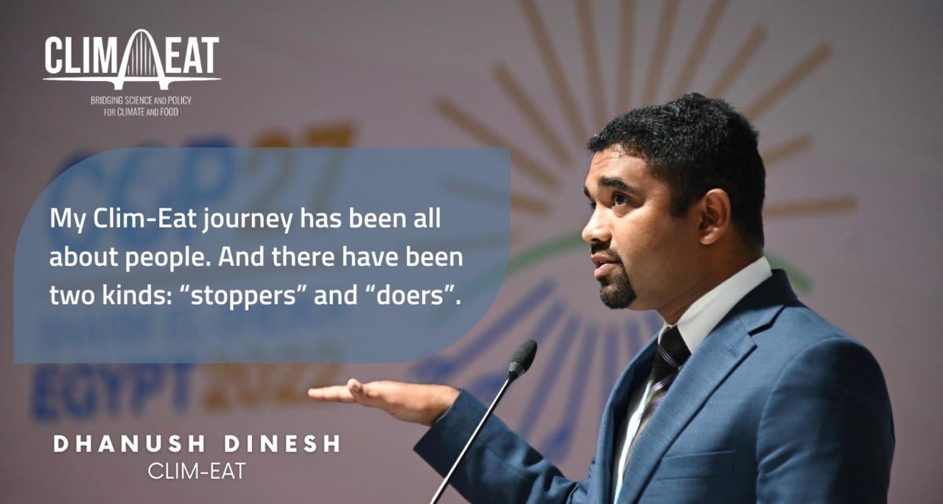
Making John Kerry blush | Clim-Eat
Food is at the literal center of nearly all cultural development worldwide. Ingredients and methods flow with care from generation to generation in an emulsion of evolution and preservation. Our calendars, holidays, and rituals are punctuated by epicurean treats, and there is no greater sign of respect for a hosted guest than a memorable, generous meal. Be it pork in China, ribeye in the US, or poulet in France, meat plays a defining role in who we are as people and how we experience well-being. The thought of meat not being available at affordable prices is inconceivable in much of the West, and its temporary scarcity has ended many a political career.
We recently predicted that the climate warrior league is rapidly losing the political center—the “soft right” and “soft left,” if you will—as its demands become more unhinged and political tactics more totalitarian:
“We have long suspected that the soft left is only willing to go so far in this regard, reasonably drawing a line to shield their standard of living. This group is now aware of the Big Lie™ sold by climate alarmists — that we can radically reduce our use of fossil fuels without meaningfully impacting our lifestyles. It was fine enough to play footsie with such assumptions when energy was plentiful and interest rates hovered around zero, but as the energy crisis unfolded and inflationary pressures took hold, the initial consequences of decoupling from fossil fuels left many quietly wondering what exactly it is they signed up for…
With COP28 approaching, quivering under the fresh sting of their weakening political power, expect the hard left’s hyperbolic rhetoric and ugly protests to accelerate.”
We expect the ongoing assault on meat to only escalate as the true believers become more desperate under the prospect of waning political influence—it might well be the issue upon which the Big Lie™ is finally made real for the plurality of everyday voters. It is one thing to buy an electric vehicle as the family spare or to install a few virtue-signaling solar panels on the roof, but giving up the filet of beef on Christmas is another matter altogether. Just how closely tied are our food habits to carbon emissions? How would limiting global meat consumption work? What can the energy market teach us about the calamitous effect of forced scarcity in animal protein? Let’s head to the farm and find out.
If energy is life, food is the mechanism by which energy directly ensures life’s persistence. Nearly all the embodied chemical energy delivered in each bite can be traced back to photosynthesis (although the journey from field to plate often involves substantial energy expenditure in its own right). For plants and vegetables, the tie to the sun is direct, whereas livestock can be viewed as longer-term energy storage devices, albeit rather inefficient ones. The controversy over meat is just another variant of the energy return on energy invested (EROEI) debate, and environmentalists view meat as an extravagant waste of our limited carbon budget.
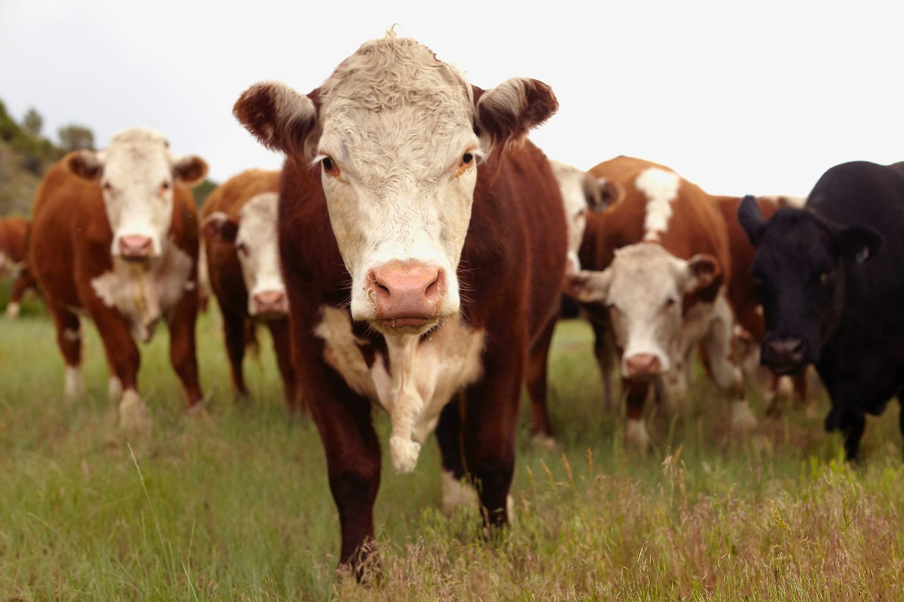
Four-legged gas guzzlers | Getty
From a strictly numerical perspective, they have a point. Emissions assigned to the agricultural sector come in two forms: those generated within the farm gate by crops and livestock activities, and those arising from changes in land use, like clear-cutting forests to expand farm acreage. Although precise numbers depend on a dizzying array of assumptions that vary greatly from country to country, the Food and Agriculture Organization of the UN assigns roughly 20% of global anthropogenic carbon emissions to our eating habits and splits them nearly equally between the two categories. How that budget is being spent is the issue de jour:
“A study on the impact of farming for instance found beef production is responsible for six times more greenhouse gas emissions and requires 36 times more land compared to the production of plant protein, such as peas.
Avoiding meat and dairy products is the biggest way to reduce our environmental impact on the planet, the study concludes. Without meat and dairy consumption, global farmland use could be reduced by more than 75%. What's more, 60% of global biodiversity loss is caused by meat-based diets, according to World Wildlife Fund (WWF) sources.”
To drive home its point, the UN developed a prioritized ranking of the carbon intensity of various foods as a function of protein content, recreated below. Studies like these feed the emissions impact statistics now being listed on food menus, a trend that is spreading to ever more restaurants and grocery stores around the world.
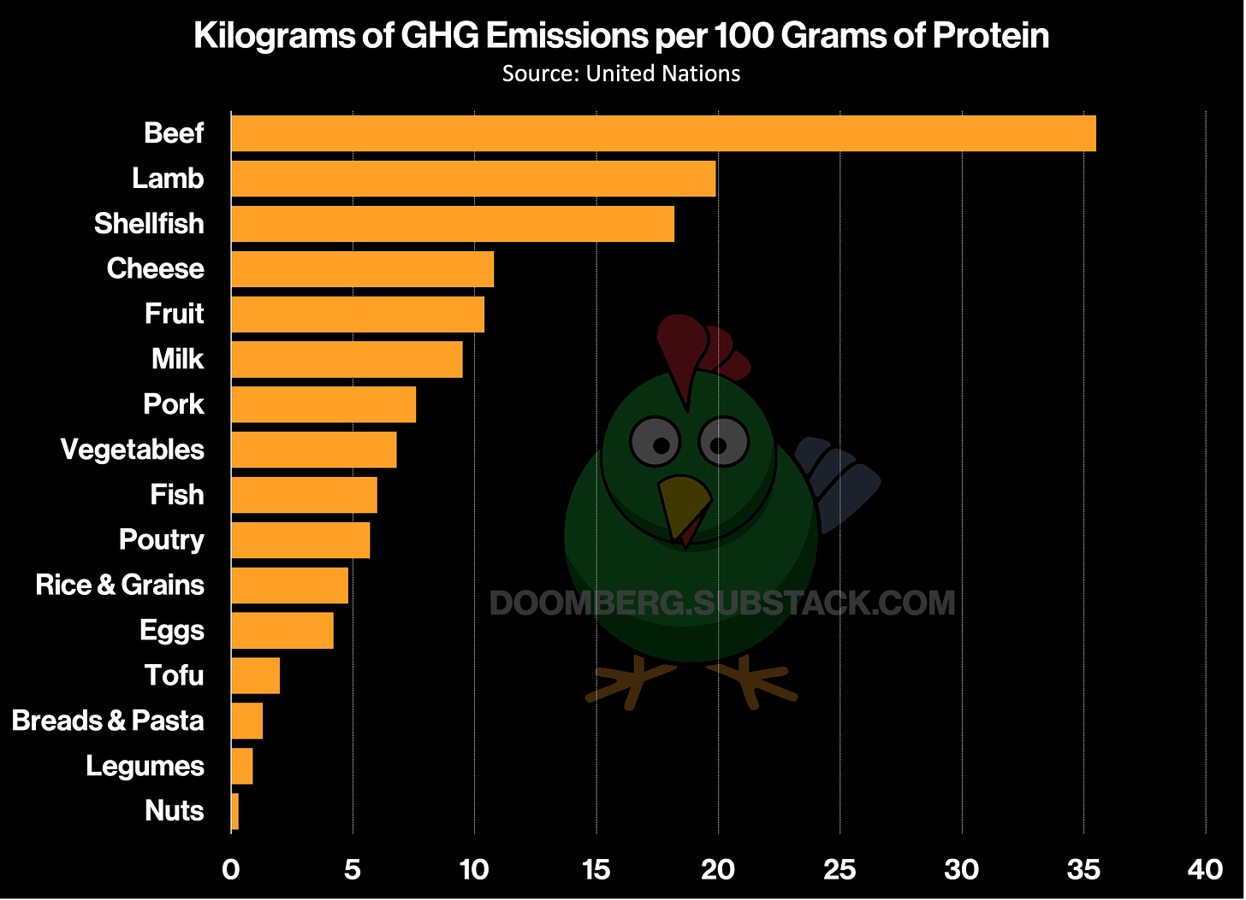
Mr. Peanut for the win
Embedded within the call for the developed world to veer vegan is a critical and unspoken assumption: To make a meaningful dent in net global carbon emissions, the developing world cannot climb the food quality ladder in its innate mission to ascend Maslow’s hierarchy of needs. To put numbers to the matter, we plotted average meat consumption against gross domestic product (both expressed on a per capita basis) for two groups of countries: the Group of Seven (G7), which includes Canada, France, Germany, Italy, Japan, the UK, and the US, and the seven most populous nations not included in the G7, namely Bangladesh, Brazil, China, India, Indonesia, Nigeria, and Pakistan. We call this latter group the P7 and note that its combined population is approaching four billion.
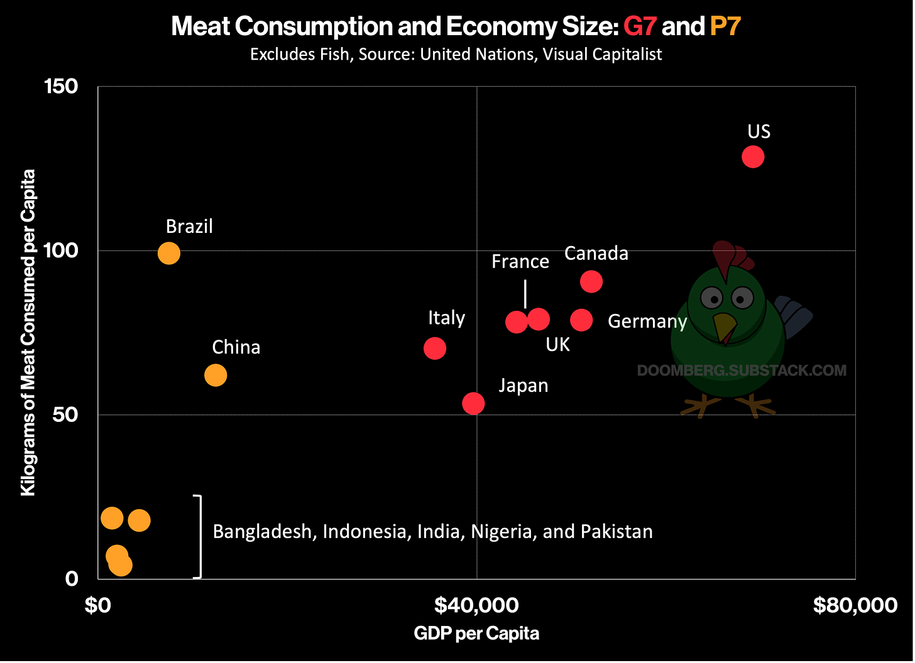
Two interesting things stand out in this chart. First, China and Brazil have the largest economies among the P7 and have prioritized the consumption of meat as an early benefit of development, ascending to levels on par with the G7. Second, the other five countries in the P7 consume almost none, and growth in demand there would quickly swamp savings elsewhere. Consider that these five nations hold seven times more people within their borders than does the US, which currently consumes almost 17 times more meat per capita than their collective weighted average.

We close by pointing out the inevitable consequences of artificially constraining the availability of meat. In the same way that a natural gas shortage in Europe resulted in record prices for coal worldwide, enforcing scarcity of the most desirous sources of protein would result in a significant inflationary pulse across the entire protein complex. In times of shortage, it is the rich who set the market clearing price for cherished goods, elevating the floor for all related commodity substitutes.
A simple thought experiment illustrates this important point. Imagine environmentalists get their way and a worldwide limit is imposed on the production of beef. It is safe to assume this would be bullish for beef prices, as the rich merely allocate more of their ample disposable income to its procurement. If the price of beef skyrockets, what happens to the price of pork? Both are globally traded commodities and somewhat fungible, but given pork’s central role in Chinese culture, the Chinese Communist Party would scramble to ensure sufficient domestic supply, tapping imports while limiting exports, thus pushing the price of pork up ever higher (pigs fly!). With both beef and pork prices soaring, what happens to the price of fish? Eggs? As the inevitable wave of protectionist trade policies is implemented, famine will undoubtedly follow.
Unfortunately for environmental theoreticians, people do not make food choices based purely on data—carbon intensity or otherwise. Similarly, they do not choose to live in the smallest house that they need, but more often the biggest they can afford. They commute in cars despite the availability of public transport for the same reason billionaires prefer to fly in private jets: life’s better that way, and isn’t everybody just striving for a better life? In the eyes of Mr. Dinesh and his ilk, this is the core problem. Too many people want too good a life, and his revealing statement (“The key problem is overconsumption”) drops the cloak meant to obscure the true Malthusian motivations at play here. This is the smallest of steps on the slipperiest of slopes to deciding who gets to live.
Like this piece or its tofu for you.

