**Are we throwing away our energy security?-Brad Hayes**

*By*[***Brad Hayes***](https://big-media.ca/my-feed/brad/)

*February 5, 2024*

<https://big-media.ca/are-we-throwing-away-our-energy-security/>

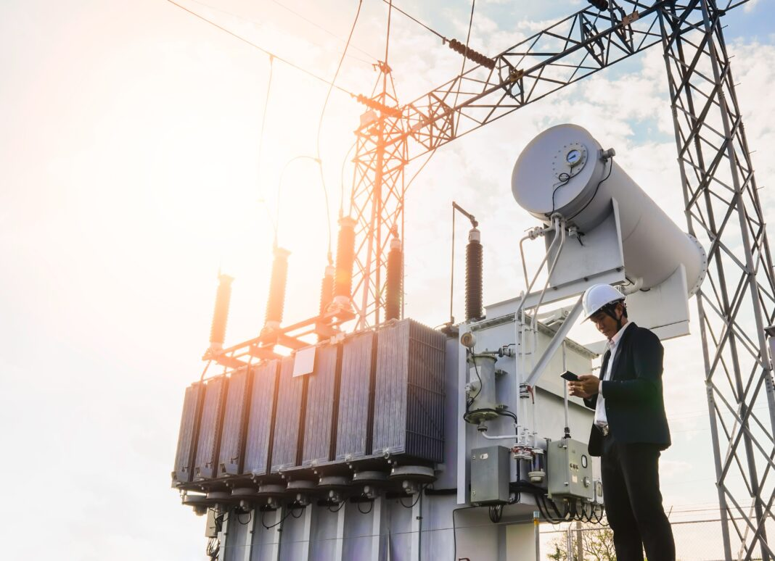

In North America, we don’t think enough about energy security. We have had abundant, affordable energy at our fingertips for so long that we forget what life might be like without it – particularly in Canada and northern parts of the United States, where millions could perish in short order if electricity and natural gas were suddenly cut off.

Is a sudden and complete cutoff of energy a real possibility? In the absence of a nuclear holocaust, the answer is no. However, government policy focused on GHG emissions reduction without adequate consideration of energy security increases the likelihood of energy shortfalls, particularly during high-demand events such as the cold snap that much of North America experienced last month.

**Mandating electricity to replace natural gas**

A recent story out of the Canadian province of British Columbia is a great example. The *Prince George Citizen* ([B.C. government considering outright ban on new standalone gas heating appliances by 2030](https://www.princegeorgecitizen.com/local-news/bc-government-considering-outright-ban-on-new-standalone-gas-heating-appliances-by-2030-8156952)) revealed that the B.C. government was considering a ban on the use of conventional gas equipment for residential, commercial, and institutional buildings. After 2030, all new space and water heating equipment in B.C. would be “at least 100% efficient” – including electric heat pumps, hybrid gas-electric heat pumps, and high-efficiency gas heat pumps. Continued use of electric resistance technologies such as baseboard and electric water heaters would be allowed, but new natural gas space and water heating would be forbidden.

Proponents claim this would be a gradual process – mandating electricity in place of gas only in new builds, and not (yet) fixing timelines for retrofits of existing heating systems. But we have to look at this process in the context of exploding electricity demand in the immediate future:

* + Thousands of new immigrants move to B.C. each year, and there is intense pressure to rapidly increase housing stock so that both new and long-time residents can afford decent homes.
  + B.C.’s liquefied natural gas (LNG) capacity is being built out so that natural gas can be shipped abroad to replace coal-fired electrical generation and high-polluting fuels such as wood and dung for home heating and cooking. LNG operators and the government want affordable electricity to reduce the emissions footprints of their facilities in a market in which reducing emissions is becoming important.
  + The federal government has mandated 100% zero-emission (electric- or hydrogen-powered) new car/SUV/light truck sales by 2035, which will result in massively increased electricity demand – particularly in smaller communities and rural areas where EV adoption has been slow to date.
  + New mines must be built to address the rapidly increasing demand for critical minerals required for low-emission energy sources and energy storage.

**Blocking new natural gas infrastructure**

Not only will proposed government policies further boost electricity demand, the British Columbia Utilities Commission (an independent regulator charged with administering B.C. legislation around utilities and energy) is taking action to block new natural gas infrastructure. FortisEnergy BC applied to the BCUC in November 2020 for the Okanagan Capacity Upgrade project to increase gas pipeline capacity to meet anticipated demand increases over the next 20 years in the rapidly growing central and northern Okanagan regions, including the urban centres of Kelowna and Penticton. Most homes and businesses in this area are heated by natural gas, which has been reliable and cost-effective for decades. Fortis’s peak-demand forecasts show an imminent capacity shortfall by winter 2026/2027, meaning the issue must be addressed quickly.

BCUC released a decision in December 2023 denying the application ([FortisBC Energy Inc. ~ Application for a Certificate of Public Convenience and Necessity for the Okanagan Capacity Upgrade Project](https://www.ordersdecisions.bcuc.com/bcuc/decisions/en/item/522057/index.do)**)**. The commission’s reasoning included this statement:

*“If the BCUC denies [the] application in whole or in part, the forecast peak demand growth in FEI’s Interior Transmission System (ITS) is highly unlikely and there is a significant risk that the forecast growth flattens or potentially begins to decline due to FEI’s inability to serve new customers’ space and water heating needs resulting from the Province’s commitments in the CleanBC Roadmap, the changes to the BC Energy Step Code and the Zero Carbon Step Code.****Accordingly, we deny the granting of a Certificate of Public Convenience for the OCU Project at this****ti****me because we****fi****nd it is not necessary for the public convenience and does not conserve the public interest.”***

In other words, by denying the application to increase gas service, the BCUC realizes it will choke off new demand by making it impossible or impossibly expensive for new housing and commercial buildings needing natural gas service – which is still legal, and preferred by many – to be built. Adding insult to injury, BCUC:

“directs FEI to examine additional potential short term mitigation solutions and develop a plan which will allow the ITS to provide sufficient peak demand capacity in the event of a 1 in 20-year cold weather event occurring in the winter of 2026/2027 or the period following.”

… and directs the mitigation plan be filed no later than July 31, 2024.

To sum up: new natural gas infrastructure will not be allowed because it might allow gas demand to increase – so by blocking the new pipeline, BCUC is OK with inadequate energy supplies that would choke off new housing and businesses in a highly desirable area of the province. But to forestall that, they direct the utility company to find some solution – any solution – as long as it is low-emission.

**Reducing emissions is clearly a higher priority than ensuring energy security for the BCUC in their interpretation of provincial legislation and government policy.**

**Where will the new electricity come from?**

Electricity demand will build rapidly in B.C. as the result of both natural growth and government policy; even BC Hydro realizes this ([Why wind power will dominate B.C.’s next power call](https://biv.com/article/2023/07/why-wind-power-will-dominate-bcs-next-power-call)). Natural gas infrastructure to service new demand is being delayed or blocked, even where no alternatives have been presented. And let’s not forget British Columbia’s failed opposition to construction of the Trans Mountain Pipeline expansion, which added years of delay and billions of dollars of additional cost to infrastructure that provides almost all liquid fuels consumed in Vancouver and Victoria.

The Trans Mountain problem has finally been addressed, but where will the new electricity come from? Let’s look at the choices:

*Hydroelectricity* – generates about 90% of B.C.’s electricity today. The newest generator on the mighty Peace River – Site C – will come on stream in 2025, after more than 10 years and $15 billion dollars. But it is more than 1,000 km from major demand centres in southwestern B.C., and new LNG facilities could consume its entire output. As well, severe drought in Peace Country in recent years has reduced hydro output, and threatens to continue to do so.

BC Hydro has called for new electrical generating capacity to be built from renewable sources – but they haven’t identified what those sources will be. What are the options?

*Solar* – Have you been to Vancouver? They go weeks at a time without seeing the sun, although summers can be pretty sunny. But land is very precious – too precious for conventional solar. The situation is better in the dry interior, but the population is relatively small.

*Wind* – There are good wind resources along B.C.’s coastline and offshore, and BC Hydro reports having 292 wind turbines in the province. But how reliable and affordable will new wind be, when equipment costs are rising, supply chains are endangered, and many projects around the world are being cancelled?

*Geothermal* – Some interesting work is happening in B.C. to tap geothermal energy for both electricity production and heat energy – Mount Meager and Tu-Deh-Kah (Fort Nelson) are two intriguing projects. But the available resource is small compared to demand, and distant from demand centres.

*Interties* – Having reliable connections to your neighbours can make electricity supply much more flexible. Denmark generates a high percentage of its power from wind, largely because it can call on Norway’s hydro, Germany’s coal, or France’s nuclear when needed. B.C. is not so lucky – there is no power generation to the north and west, Alberta to the east runs on natural gas and has its own problems, and American states to the south are also suffering drought-induced hydro shortages. B.C. is already calling heavily on intertie capacity to cover reduced hydro output.

And there is renewable natural gas (RNG) – not electricity, but energy – but only sufficient to heat 3,470 homes per year ([Provincial and Territorial Energy Profiles – British Columbia](https://www.cer-rec.gc.ca/en/data-analysis/energy-markets/provincial-territorial-energy-profiles/provincial-territorial-energy-profiles-british-columbia.html)).

B.C.’s provincial government and BC Hydro have launched a 10-year, $36-billion capital plan to invest in new infrastructure ([Premier announces new actions to build electricity system, create jobs](https://news.gov.bc.ca/releases/2024EMLI0002-000049#:~:text=BC%20Hydro's%20goal%20is%20to,electric%20dams%20act%20as%20batteries)). They mention new high-voltage transmission lines, new substation infrastructure, and upgrading generation facilities to make them safer, more reliable, and more efficient. All great stuff. But the only new generation mentioned are unspecified “intermittent renewables” projects.

Regardless of which new generation is chosen, when will it be available? Look at Site C – more than 15 years from conceptualization to completion.

**Summary**

British Columbia is a dynamic, thriving province with abundant natural resources and a growing population. Electricity demand has been growing moderately but promises to take off as heavy new loads materialize – new mines, new LNG facilities, and replacement of oil and gas energy by electricity.

“Clean” energy and emissions reduction are the key points for governments and the utilities commission. New rules around heating homes and business are being considered, electric vehicle mandates are in place, and at least one natural gas distribution project has been blocked despite imminent supply shortfalls to a large region.

The provincial government and BC Hydro talk about ensuring B.C.’s energy future, but there appears to be no firm plan to generate the required electricity. **Emissions reduction is being prioritized over energy security.**

**B.C. may well be throwing away its energy security.**