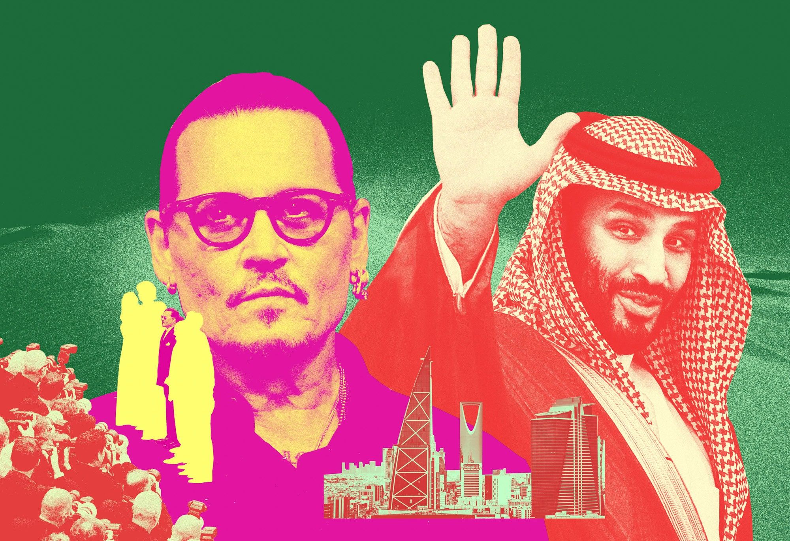
PHOTO ILLUSTRATION: KHOA TRAN. SOURCE IMAGES: ABDULLAH ALE ISA, LUDOVIC MARIN, MIKE COPPOLA, TIM P. WHITBY, SIDSEL CLEMENT. ALL: GETTY IMAGES.

FROM THE MAGAZINE

Inside Johnny Depp’s Epic Bromance With Saudi Crown Prince MBS
The stranger-than-fiction story of how Mohammed bin Salman welcomed the 60-year-old movie star into his kingdom—and his circle of trust.
BY BRADLEY HOPE
FEBRUARY 14, 2024
An ornately clad royal, draped in velvet and frills, sits at his dressing table within the hallowed halls of Versailles awaiting a final dusting of powder. Just then, a courtier bursts in with an urgent message concerning the Kingdom of Saudi Arabia.
But this is not the 1700s, and the man in the chair is not King Louis XV. It’s July 2022, and Johnny Depp, of Owensboro, Kentucky, is having his hair and makeup done for his role in a French period piece titled Jeanne du Barry. The messenger is a senior producer with a surprising request: Prince Badr bin Farhan Al Saud wants to meet with Depp..

The prince, an amiable fellow with a toothy grin, is Saudi Arabia’s culture minister—and a cousin of the omnipotent Crown Prince Mohammed bin Salman, known as MBS. In 2017, Prince Badr made headlines when he served as the front man for MBS’s purchase of the world’s most expensive painting, Leonardo da Vinci’s Salvator Mundi. Price tag: $450 million.
Not that Depp cares. “No way,” he tells the producer. “I didn’t sign up for this.”
The catch, however, is that Prince Badr has suddenly become very important to the production of Jeanne du Barry. By investing millions in the project via Saudi Arabia’s Red Sea Film Fund, he has earned the right to an audience with the star.
“They made a genuine connection,” says a friend of Depp’s. “It’s a shock to many of the people who know him, but it’s what happened.”
After a few days of back-and-forth, Depp reluctantly agrees to the meeting. It goes so well that, within months, the 60-year-old actor, known for palling around with the likes of Keith Richards and the late Hunter S. Thompson, will stand face-to-face with MBS, the 38-year-old de facto ruler of Saudi Arabia.
Theirs will be a bromance like no other.
With his willingness to spend billions of dollars in a relentless drive to transform his country into a cultural and economic superpower, MBS is shaking up the world order. To decipher his increasingly consequential moods, methods, and moves, global leaders rely on thousands of diplomats, linguists, and spies.
They should probably just call Depp.
Over the past year, Depp has spent more than seven weeks in Saudi Arabia, staying in royal palaces and camps, traversing the country by yacht and helicopter, and even flying to London and back on MBS’s personal 747 for a quick trip to attend the Jeff Beck Memorial Concert at the Royal Albert Hall.
In that time, Depp and MBS have become real friends. “They made a genuine connection,” says a friend of Depp’s. “It’s a shock to many of the people who know [Depp], but it’s what happened.” Insiders say Depp is now weighing a seven-figure annual contract to promote Saudi Arabia’s cultural renaissance.
Both men knew how it felt to suddenly go from golden boy to outcast. Depp’s stock had taken a hit after his ex-wife Amber Heard accused him of abuse. In two high-profile court cases, Depp contested those claims, which he has always denied. As Depp and Heard wrangled in court in the second case, a cascade of unflattering personal details hit the press and social media. The ugly spectacle, and the troll war it sparked, damaged Depp’s reputation in some circles.
For MBS, it was the horrific murder of journalist Jamal Khashoggi at the hands of Saudi state operatives in 2018 that sent shudders around the world, irrevocably tainting the crown prince’s carefully cultivated image as a brilliant young reformer.
Reached for comment, Johnny Depp said, “Though I admit I was somewhat naive at first to what was transpiring in the region, I’ve since experienced firsthand the cultural revolution that is happening there—from emerging young storytellers radiating fresh ideas and works of art to a blossoming film infrastructure and a newfound curiosity for innovation. I’ve had the opportunity to meet people from various parts of the region who have been most welcoming in sharing with me their culture, their traditions, and their stories.”
Depp’s introduction to Prince Badr was set in motion by Sina Taleb, a French wheeler-dealer whose famous friends include Leonardo DiCaprio and Tobey Maguire. During a chance meeting in Cannes, Taleb and Badr got to talking about how to bring more A-list talent to the kingdom to support its burgeoning film industry.
Rather than paying actors to visit, an inherently cynical transaction, Taleb said Saudi Arabia should invest in films to demonstrate its commitment to the arts.
Under MBS’s ambitious Vision 2030 plan, Saudi Arabia is plowing hundreds of billions of dollars into a kaleidoscope of ventures—everything from mining and real estate to sports and tourism. The goal is to develop new revenue streams and kick the kingdom’s addiction to oil money.
Entertainment is a key focus because it not only increases tourism but also persuades more of the country’s 30 million residents to do their leisure spending domestically. Under the draconian rules that MBS started to wipe away in 2015, entertainment was highly constrained: Playing music in public was banned, men and women couldn’t easily mix, and even simple pleasures like going to the movies were unheard of.
Eight years later, the country is booming with cultural activity, some of which reflects the personal interests of its all-powerful crown prince. He’s said to be a big video gamer, and Saudi Arabia has plans to invest $38 billion in esports and gaming. He’s also believed to be an amateur DJ who loves electronic dance music, and the country now hosts the Middle East’s biggest music festival, Soundstorm, every December.
“We’re making up for lost time and making sure that our country realizes its potential,” a Saudi government adviser says of the country’s huge entertainment push.
Back in the early ’60s, Lawrence of Arabia was shot in Jordan, Morocco, and Spain. At the time, filming in the kingdom was all but prohibited. Today, productions are flocking to Saudi Arabia for the scenery, yes, but also for the rebates, which can rise as high as 40 percent of the budget.
“It’s not just a prince saying I want to have Tom Cruise come here,” says producer Jonathan Gray, who first met MBS in France in the early 2000s. “It’s the economy.”
According to Gray, MBS is a sci-fi aficionado. “It’s really the capacity to escape your mind, thanks to worlds so different from ours, that makes it special for him,” he says.
In 2021, Gray’s company, The Hideaway Entertainment, and Anthony and Joe Russo’s AGBO shot scenes for Cherry, the first major Hollywood production filmed in Saudi Arabia since MBS’s ascension six years earlier. (The 2012 drama -Wadjda was the first feature to be shot entirely in Saudi Arabia.) Starring Tom Holland as an American college dropout who grapples with PTSD after serving as a medic in Iraq, Cherry was distributed by Apple TV+ and debuted to middling reviews.
Gray says he’s now developing Saudi stories for an international audience. One initiative is building a horror franchise around the invisible spirits known in Islam as djinn. His company receives funds for financing and development through a $50 million vehicle called Meridian Entertainment Fund, whose investors include Saudi nationals.
Still, luring the biggest names in Hollywood takes more than cash. Many in the industry are nervous about the reputational risks of associating with Saudi Arabia. Khashoggi’s murder is a major concern, and he’s far from the only critic who has been targeted. Countless others have been arrested and detained. The kingdom also has a dismal human rights record and backward positions on LGBTQ+ rights, freedom of speech, and other issues generally sacred to Western liberals.
Martin Scorsese declined an invitation to attend the Red Sea Film Festival last year, but not everyone is so skittish. The 2023 Features Competition Jury was presided over by Baz Luhrmann, the Australian director of Elvis, The Great Gatsby, and Moulin Rouge!. Others spotted on Jeddah’s red carpet in recent years include Sharon Stone, Priyanka Chopra, and the Bollywood star Shah Rukh Khan. (Vanity Fair Europe has partnered with the Red Sea Film Festival on several events.)
MBS relies on two members of his inner circle, both old friends, to cultivate foreign entertainers and athletes: Prince Badr and Turki Al Sheikh, chairman of the General Entertainment Authority.
A Ministry of Interior official turned “poet” who regales his 18 million Instagram followers with his latest compositions, Al Sheikh, 42, is the life of the party. One of his initiatives is the Riyadh Season, an annual series of concerts and spectacles, including a fountain show worthy of the Las Vegas Strip. Last year’s event featured a boxing match between WBC heavyweight champion Tyson Fury and MMA star Francis Ngannou. A die-hard soccer fan, Al Sheikh has also helped lead the charge to bring such icons as Cristiano Ronaldo and Neymar to Saudi Arabia’s Pro League.
Meanwhile, Prince Badr, born two weeks before MBS, plays the cultural ambassador, attending events like the Venice Biennale and meeting the heads of museums. In the last few years, he has developed a coterie of prominent friends who, in turn, introduce new prospects to Saudi Arabia. Among them is rapper Swizz Beatz, the husband of singer Alicia Keys, who has spent considerable time in the kingdom over the past several years. He shot an episode of his Hulu show, Drive With Swizz Beatz, in the Saudi desert.
Swizz has a long history of advising the ultrarich on art collecting. Before Jho Low, the alleged Malaysian fraudster, went on the run from the Department of Justice and other investigators, Swizz helped persuade him to purchase Jean-Michel Basquiat’s Dustheads for $48.8 million.
Now, Swizz is advising Prince Badr on art acquisitions. If there are plans to display Salvator Mundi, they are closely guarded. Friends have learned not to ask because Badr tends to excuse himself from the room whenever the painting is mentioned.
Badr recently Instagrammed a photo of himself and Saudi Arabia’s vice minister of culture, Hamed Fayez, with basketball legend LeBron James and his business partner Maverick Carter. Swizz wrote in a comment, “My brothers .” Like Depp, James and Carter were introduced to Saudi Arabia by Taleb.
Intrigued by Taleb’s advice to invest in Hollywood projects as a way of luring A-list talent, Prince Badr asked him to find some films that needed funding.
“These guys mean business,” Taleb says.
So in the summer of 2022, he called an old friend named Thomas Langmann, who had produced The Artist. Taleb says Langmann gave him two ideas: Francis Ford Coppola’s Megalopolis and Jeanne du Barry, starring Johnny Depp.
It turned out that Coppola didn’t need—or want—any additional money, but Jeanne du Barry was struggling to come in under its tight budget.
With Taleb’s help, Prince Badr and the film’s producers arranged for Saudi Arabia to invest millions to cover budget overruns and some additional expenditures. The film’s final budget was $22.4 million.
Everything seemed in order until Prince Badr asked to visit Depp on set. At the time, the royal cousin was staying nearby in one of MBS’s houses. The $300 million château, set on a 57-acre site complete with moats, is called Château Louis XIV.
Depp’s wariness had to do with another Saudi prince he’d spent many years carousing with in New York and Paris and on the Mediterranean coast. Prince Abdulaziz bin Fahd—the fabulously wealthy son of the former King Fahd, MBS’s uncle—famously traveled the world with an entourage of two dozen hedonistic associates. They rented yachts, bought out restaurants, and generally partied nonstop.
There was a dark side to these escapades. In 2012, a member of his retinue was convicted of raping a woman at the Plaza Hotel in Manhattan, where the prince had rented out a block of rooms.
Suddenly, in 2017, Prince Abdulaziz stopped appearing in public. It turned out that he was caught up in the so-called sheikdown, wherein MBS suddenly detained close to 300 of Saudi Arabia’s richest men, including his own relatives, on suspicion of corruption. The majority were held at the Ritz-Carlton hotel in Riyadh, the same venue that weeks earlier had hosted visiting CEOs and dignitaries for the annual Future Investment Initiative conference.
Many of the detainees were released after giving up a portion of their fortunes, but a few have yet to reemerge publicly. One of them, former Riyadh governor Prince Turki bin Abdullah, had allegedly been plotting against MBS.
Depp’s friend Prince Abdulaziz eventually resurfaced, smiling for a photo beside MBS, but he has kept a very low profile ever since.
Upon hearing Depp’s reasons for not wanting to meet, Prince Badr was able to reassure the actor that his old friend had been released following a temporary detention. He said Depp was welcome to meet with Prince Abdulaziz in Saudi Arabia and even offered to let him look at the official corruption case file at one of the Saudi embassies in Europe.
The openness worked and the two men met. A few months later, Prince Badr’s team persuaded Depp to fly to Jeddah for the 2022 Red Sea Film Festival. Once Depp arrived, however, he skipped the public events. Instead, a team led him on a tour around the country.
It was Depp’s first visit to Saudi Arabia, and he looked around wide-eyed at the changes underway. One person familiar with the trip said Depp bonded with Prince Badr but also talked to a wide range of people—drivers, desert guides, young artists, and members of the royal court.
By the end of the visit, Depp had apparently proved himself worthy of meeting the crown prince himself. They hit it off instantly.
Depp’s friends in London were alarmed when they heard about his budding relationship with MBS.
But the edginess appealed to Depp, who was still recovering from the chaotic aftermath of his divorce from Heard, those friends say. He seemed refreshed by the time away from his hard-drinking friends in Europe and the crowd that surrounds his rock band, the Hollywood Vampires.
“The trips to Saudi are actually healthy for him,” a friend says. Drinking is technically prohibited in Saudi Arabia, but VIP guests are still treated to alcohol in private settings, especially on yachts because, as they see it, they are technically not on Saudi soil.
Moreover, Depp, who did not recognize himself in the tabloid coverage of the Heard trial, was beginning to question the Western narrative about Saudi Arabia. The crown prince said the world had unfairly tarnished him as a bloodthirsty dictator in the vein of Saddam Hussein. This was Saudi Arabia’s greatest moment, he told Depp, a major transformation perceptible even on a monthly basis, if people would only bother to visit.
“He became a believer that this is actually a country in the midst of a cultural revolution,” Taleb says.
One of the key stops on Depp’s tours with MBS and Prince Badr was AlUla, an ancient oasis city that had been off-limits before MBS came along. The authorities never said why the city was closed off, but it probably had something to do with a story in the Quran about how God punished the people of the area, known as Madain Saleh, with an earthquake that made it inhospitable to human life.
There was also concern that Saudi Arabia’s once-powerful religious conservatives would destroy the petroglyphs carved into AlUla’s cliffs by the same pre-Islamic civilization that settled Petra in Jordan.
But under MBS, who has espoused a more liberal and personal form of Islam, AlUla has become the center of a high-end cultural explosion. Each year, its contemporary performing arts center, Maraya, nestled in a canyon and clad completely in mirrors, hosts events for the Winter at Tantora festival.
On his second visit, in early 2023, Depp was invited to MBS’s royal camp in the mountains, with trained falcons, luxury tents, and an outdoor kitchen tended by dozens of staff, all accompanied by sweeping views.
One night, Depp summoned the courage to ask MBS a simple but potentially explosive question: What really happened with Khashoggi?
He also flew on multiple occasions by helicopter to MBS’s yacht, Serene, one of the largest in the world. The 439-foot vessel mostly travels around the Red Sea as part of a floating palace complex, with as many as a dozen other smaller boats providing additional space for guests and crew. Depp always brings his guitar, according to a person familiar with the visits.
The yacht is set up to serve as a mobile statehouse. MBS hosted Secretary of State John Kerry there in 2015. But with the touch of a few buttons, it can be turned into a nightclub with state-of-the-art DJ equipment.
MBS and many of his advisers are night owls, staying up all night and sleeping well into the day. It’s a habit that MBS acquired as a teenager, and some, like his younger brother Khalid bin Salman, the defense minister, find it helpful to be on the same schedule as counterparts in the US.
Depp likes to burn the midnight oil too, and he and MBS would stay up late talking about the crown prince’s plans for Saudi Arabia and Depp’s thoughts on how to bring more art and filmmaking to the country. At one point, Depp gave the prince a painting he’d made.
One night, Depp summoned the courage to ask a simple but potentially explosive question: What really happened with Khashoggi?
A veteran journalist with ties to both Saudi intelligence and the Muslim Brotherhood, Khashoggi had been living in Turkey and the US and had become an increasingly vocal critic of MBS’s rule, chastising the crown prince in The Washington Post and elsewhere for the war in Yemen and his aggressive moves to silence critics on both sides of the political spectrum. In October 2018, Khashoggi visited the Saudi consulate in Istanbul to obtain paperwork that would allow him to marry his Turkish fiancée. Once inside, he was drugged, killed, and dismembered by Saudi operatives.
A listening device installed by the Turkish government captured the cold-blooded murder in excruciating detail. Its release shattered the image of MBS internationally and led to a widespread, if unofficial and inconsistent, boycott of all things Saudi for a few years. Joe Biden promised to make Saudi Arabia a “pariah” state in the run-up to the 2020 election.
MBS denied ordering the hit but admitted he was ultimately responsible for Khashoggi’s death. Many of those involved in the operation were put on trial, and several were sentenced to prison. For about three years, MBS reduced his travel and focused inwardly on his Vision 2030 plan. Observers speculated that his family would remove him from power and return Saudi Arabia to its traditionally glacial status quo. They were wrong.
By 2022, the furor had subsided enough that MBS felt comfortable answering Depp’s question. With an earnest expression, MBS began laying out his argument that Khashoggi had become a rogue operative working with the country’s enemies to undermine the crown prince’s reform agenda. The West saw Khashoggi as a journalist, MBS said, but the royal court viewed him as a corrupt enemy of the state, putting its future at risk for hidden motives.
MBS said that his staff had been ordered to arrest Khashoggi on criminal charges if the opportunity arose but that the directive had been misunderstood by overeager underlings who believed the prince would be happy if Khashoggi were silenced permanently. Consistent with his public statements, MBS told Depp he didn’t order the murder but nonetheless took responsibility.

The CIA said in a confidential assessment that it believed with high confidence MBS ordered the killing, The Washington Post and The New York Times reported in 2018.
The bromance is now in full gear, people close to Depp say. And naturally, being close to the crown prince of Saudi Arabia has its benefits.
Depp maintains to anyone he discusses the topic with that he values the friendship for what it is and doesn’t want anything in return.
But to secure Depp’s assistance in putting Saudi Arabia on the cultural map, his team is in talks with the Saudi government about an annual seven-figure deal for him to attend events and shoot films in the country. In December, he attended the Red Sea Film Festival for the regional premiere of Jeanne du Barry.
Earlier in the year, the Red Sea Film Foundation, through its financing arm, announced an investment in Depp’s next directorial effort, Modi, about Italian artist Amedeo Modigliani. As part of the arrangement, Saudi interns have worked on the project across every department.
The plot of the film, which stars Al Pacino and the Italian actor Riccardo Scamarcio in the title role, bears some semblance to Depp’s own recent personal and professional journey. It takes place over two days as Modigliani hits rock bottom, drunkenly alienating those closest to him.
According to a press release from the Red Sea Film Foundation, the “chaos reaches a crescendo when he’s faced with a collector who could change his life.”

