Why the death of North Sea oil is a disaster for Britain

Having squandered its most valuable asset, the UK has left itself dangerously exposed.

[Jonathan Leake](https://www.telegraph.co.uk/authors/j/jk-jo/jonathan-leake/) *and* [Szu Ping Chan](https://www.telegraph.co.uk/authors/s/su-sz/szu-ping-chan/)7 April 2024 • 6:00am

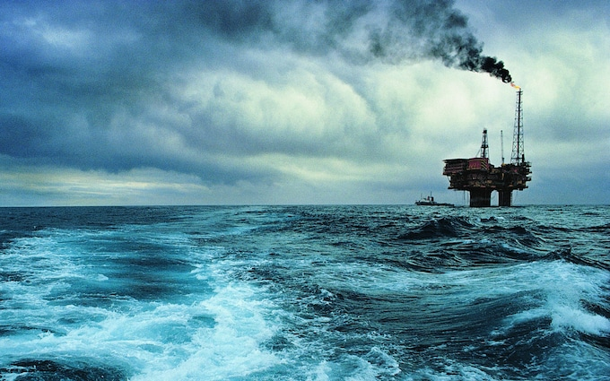

Decommissioning is the new name of the game – despite an estimated 25 billion barrels of untapped oil CREDIT: Getty Images Contributor/Michael Saint Maur Sheil

Far out in the North Sea a deserted but massive oil platform awaits its fate. Brent Charlie is the last remainder of the Brent field – a resource so big it once provided a third of the UK’s daily oil needs.

Discovered in the 1970s, the Brent field at one point produced 184 million barrels of oil a year, earning billions for Shell, its owner, plus £20bn in tax revenues for the Exchequer. It was so big it needed four massive platforms to extract its riches – Brent Charlie, Alpha, Bravo and Delta.

Today Alpha, Bravo and Delta have gone, cut from their supports and taken to the scrapyards.

Later this year Brent Charlie will also have its legs cut from under it and be lifted on to Pioneering Spirit – a giant ship specially designed to rip apart decaying oil and gas installations.Advertisement : 14 sec

Pioneering Spirit and the growing fleet of similar oil rig-slaughtering vessels are set for some busy years. In the waters around the UK, hundreds more oil and gas installations are falling silent. Fifty years after the North Sea bonanza began, the final decline is upon us.

As well as hauling the retired rigs to shore, nearly 8,000 wells that were drilled deep into the seabed must also be plugged.

The decline of the North Sea has implications not just for energy policy and tax income, but public finances more broadly.

We face a huge bill – potentially up to £60bn – [to clean up the North Sea](https://www.telegraph.co.uk/business/2024/04/02/taxpayer-foot-shell-bill-dismantle-toxic-north-sea-oil-rigs/).

The energy companies are responsible for decommissioning, but tax breaks mean much of that money will be reclaimed from the Exchequer - and ultimately taxpayers.

Last year alone more than 200 oil and gas wells were plugged, eight platforms were removed and 8,000 tonnes of subsea structures were taken out of the ocean – with another 250km of seabed pipelines being decommissioned. Another 180 of the UK’s 284 oil and gas fields will close down by the end of the decade.

Mass closures are not the result of eco-protests, nor because of a lack of demand.

Supply isn’t dwindling either. Over the last five decades oil and gas equivalent to 47 billion barrels of oil have been extracted, but seismic surveys suggest another 25 billion remain.

Instead, operators blame punitive taxes for the rapid pullback, with [some facing levies of more than 100pc on their profits](https://www.telegraph.co.uk/business/2024/03/28/north-sea-oil-enquest-demands-windfall-tax-overhaul-losses/#:~:text=It%20meant%20oil%20and%20gas,rates%20in%20excess%20of%20100pc.).

Production is now in rapid decline.

Data from the North Sea Transition Authority (NSTA), the government’s regulator, shows UK oil production peaked at 150 million tonnes of oil a year in 2000 – roughly double the nation’s consumption. We also produced about 108 billion cubic metres of gas – about 20 billion more than we consumed.

Exports, jobs and taxes were all booming. The oil and gas industry was employing 500,000 people directly or in its supply chains and its products were the essential fuels powering not just our homes and vehicles but the whole UK economy.

Over the five decades to 2020 the offshore industry poured around £400bn of taxes into the Treasury’s coffers.

The contrast with now could hardly be greater. Last year the UK produced just 38 million tonnes of oil, down by 74pc from its peak and about 20 million tonnes less than we need. Gas production was 30 billion cubic metres – less than half our needs.

Employment has fallen to 130,000. So too has the tax take, to around £3bn.

Meanwhile, the UK’s reliance on oil and gas has hardly changed. We still get 75pc of our total energy from oil and gas – just like two decades ago.

Fossil fuels may be warming the climate but they are also essential to heating the 27 million homes reliant on gas or oil-powered boilers. Around 30 million vehicles still run on diesel or petrol and gas-fired power stations provide over a third of our electricity.

We still consume 77 billion cubic metres of gas a year or 1,100 cubic metres per person, the volume of 14 double-decker buses. We also consume about 60 million tonnes of oil – nearly a tonne per person. Imagine several wheelie bins of oil for each citizen, including children.

Whatever the green lobby claims and whatever politicians promise, the fact is that the UK remains a fossil-fuelled nation.

Will that change? Fossil fuel consumption has declined a little and should fall faster if the Government can persuade us to [install heat pumps](https://www.telegraph.co.uk/money/net-zero/why-get-heat-pump/), buy electric cars and change our lives in all the other ways required by net zero.

But what’s becoming all too clear is that our consumption of fossil fuels will never fall as fast as the decline in our North Sea supplies.

It means that for at least the next few decades the UK will be increasingly reliant on imports – with all the vulnerability to global markets, price shocks and the whims of dictators such as Putin that this implies.

Two decades ago we were producing enough oil and gas for the nation and exporting some. Now we face energy poverty and reliance on other nations to keep our homes warm, our lights on and our vehicles moving.

How did it come to this?

Black gold

“Dear God, give us another oil boom. Next time we won’t p*** it up against the wall”.

The words of an anonymous graffiti artist scrawled on a wall some years ago in Aberdeen still resonate today.

The city’s roots as the UK’s oil and gas capital can be traced back to the mid-1960s when BP discovered the West Sole gas field, the first confirmation that more fossil fuel riches were waiting to be found in the North Sea.

Other companies soon came looking, with Philips Petroleum discovering Norway’s mighty Ekofisk field in 1969, followed by the UK’s colossal Brent field in 1971 and the Piper field in 1973.

These giant oilfields and others like them offered the potential to transform the UK’s economic landscape.

Tony Benn welcomed the first delivery from the Argyll field. A famous picture shows the then-Labour energy secretary opening a valve to release the first consignment of oil into the BP refinery on the Isle of Grain in Kent.

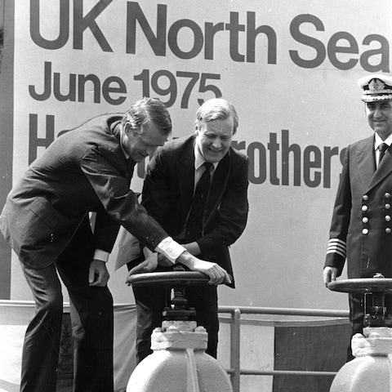

Tony Benn (centre) turns the tap on to bring the first flow of North Sea oil ashore in 1975

Tax receipts also started flowing in, hitting a record high of £12bn in the mid-1980s.

At its peak, roughly one in every £12 that the UK Government took in tax revenues came from the sector.

Today, that figure is less than £1 in every £100.

The oil boom sparked huge shifts in Britain’s economy as the pound soared in value, rendering huge swathes of British industry uncompetitive and destroying thousands of jobs.

It also helped to bankroll Thatcher’s tax-cutting drive in the late 1980s, cementing her legacy as a big reformer.

Politicians knew at the time they had a cash cow, and successive chancellors have been milking it ever since.

First came the petroleum revenue tax (PRT), introduced alongside the discovery of oil and gas. A new 20pc tax on North Sea oil was introduced in 1981 by Tory chancellor Geoffrey Howe.

Labour’s Gordon Brown introduced a 10pc “supplementary charge” on North Sea profits in 2002, effectively raising tax on the region’s production to 40pc from 30pc. He launched a second raid on profits in 2005 by doubling the supplementary charge in what the SNP branded a £2bn “smash and grab”.

George Osborne tinkered with North Sea taxes further, launching a £2bn raid in 2011 to pay for a one penny cut in fuel duty as oil prices soared above $100 a barrel.

Jeremy Hunt’s windfall levy in the wake of Russia’s invasion of Ukraine helped to plug a hole in the public finances.

Countries such as Norway have taken a very different approach to managing their oil and gas wealth.

In 1990, when the UK was using its North Sea income to fund battles against the unions and prop up day-to-day finances, Norway set up a giant savings account – now known as a sovereign wealth fund.

That fund today controls assets worth £1.5 trillion, including a stake in 113 buildings on London’s Regent Street ranging from Apple’s flagship store to Hamleys toy shop.

Norway’s sovereign wealth fund today holds the equivalent of about £250,000 for each citizen – enough to make the nation comfortable for many decades to come, including long after the oil and gas runs out.

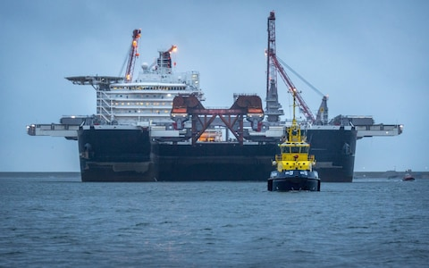

The Pioneering Spirit is busy ripping apart what's left of Britain's oil rigs CREDIT: LEX VAN LIESHOUT/AFP via Getty Images

There were people advocating for a similar UK North Sea wealth fund at the time of the industry’s beginnings. Labour’s Tony Benn was one of them, as was Bruce Millan, the former Scottish secretary of state. But they were overruled by the rest of the cabinet, who were becoming wary of the growing calls for Scottish independence.

Denis Healey, the former Labour chancellor, admitted in one of his final interviews that the government did “underplay the value of the oil to the country because of the threat of nationalism”.

Sukhdev Johal, accountancy professor at Queen Mary University, London, estimates that if the UK had set up a similar fund to the Norwegian it would be worth £850bn. Given the UK’s much larger population, that would work out to £13,000 per person – a smaller haul, but still significant.

Ultimately, the North Sea income helped support tax cuts for the better-off when the Tories ousted Labour. Nigel Lawson, chancellor under Margaret Thatcher, had cut the top rate of tax from 60p to 40p by 1988.

Healey told Holyrood magazine: “Thatcher wouldn’t have been able to carry out any of her policies without that additional 5pc on GDP from oil. Incredible good luck she had from that.”

Today the North Sea isn’t the cash cow that it used to be and the money is swiftly running out.

Operators’ revenues were £10bn in 2022-23, the Office for Budget Responsibility (OBR) estimates, but this is projected to fall to £4bn this financial year and just £2bn by 2028-29.

Production costs are also mounting. Decades of extraction mean all the easily accessible oil has already been drilled out.

The UK’s mature fields are now one of the most expensive places in the world to extract oil from. It costs $26.20 to produce a barrel of the stuff today, compared with $5.50 in Saudi Arabia and $7.30 in Norway, according to Rystad Energy.

Scrapheap challenge

The big challenge today is decommissioning.

Six years ago the NSTA estimated that the cost of dealing with all the rusting remains of the UK’s North Sea ventures was £60bn. Its scrapheap challenge includes 320 fixed installations, 250 “subsea systems” – meaning wellheads and other kit on the seafloor – plus 20,000 miles of pipelines snaking between wells, platforms and the shore.

But the costliest challenge is dealing with the 7,800 wells, which often stretch over a mile into the bedrock. Each needs to have sections of its steel casings stripped out and plugged with cement, a process likely to consume half the entire decommissioning budget.

“Each unplugged well is a threat to the future, potentially leaking pollutant oils or methane, a potent greenhouse gas, into the ocean above for decades or centuries,” says one of the industry’s most experienced engineers.

For the Treasury, however, the problem is not future pollution but cost.

The UK treats decommissioning as a business expense, meaning it can be offset against profits made in previous years to lower tax bills. Shell’s Brent clean-up alone has cost the Treasury £600m in tax rebates since 2018.

Just how much the end of the North Sea will ultimately cost taxpayers is a bone of contention.

The National Audit Office (NAO) estimated the Treasury faced a £24bn bill for such rebates in a 2019 report.

“Taxpayers are ultimately liable for the total cost of decommissioning assets that operators cannot decommission,” the NAO said.

The warning prompted the Treasury to put pressure on the NSTA to cut the cost of decommissioning. Its latest predictions show an astonishing reduction in the total cost from £60bn to £40bn, which combined with increases in oil prices and profits has reduced the Treasury’s predicted liability to £4.5bn.

Some critics suspect a politically inspired accountancy exercise, but the NSTA says the savings are genuine. It insists that knowledge-sharing and “more sophisticated” forecasting have helped, adding: “Setting cost reduction targets sharpened industry’s focus on the need to improve.”

Industry insiders beg to differ, questioning how any sector could slash costs by a third in an era of rampant inflation.

Gilad Myerson, executive director of Ithaca Energy, one of the UK’s largest offshore operators, said the NSTA’s estimates took too little account of the impact of the UK windfall tax, which has restricted investment and “will bring forward the timing of decommissioning programmes whilst reducing production from existing UK fields”.

Myerson says: “These changes to fiscal policies were designed to boost taxes, but in reality will cost the economy more as fields shut early, reducing tax payments and driving up decommissioning costs.”

More than 250 decommissioning plans have been lodged so far. Each sets out in detail what will be removed but also what will be left in place, including pipelines, concrete mattresses (used to protect pipelines) and other redundant metalwork or concrete.

In theory all such dumping is banned under the Ospar Convention on maritime pollution, an agreement between the UK and 14 other European governments, plus the EU, aimed at protecting the north-east Atlantic.

In practice, however, a relaxed approach from the regulator means the UK’s seabeds will never be put back to their natural state – a saving that will benefit companies and the Treasury, but infuriate environmentalists.

More cost savings may come from derogations, where Ospar signatories permit companies to leave massive installations in the sea forever despite official rules.

The UK has approved 10 such derogations and Ospar warns many more are likely: “There are currently 59 steel installations weighing more than 10,000 tonnes and 22 gravity-based concrete installations, for which [more] derogations from the dumping ban may yet be considered.”

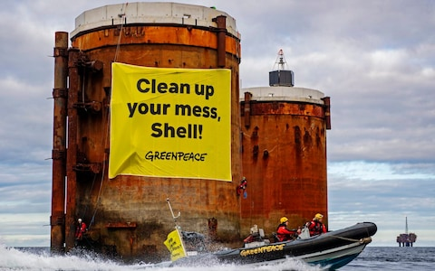

Ageing oil rig structures left to rust in the North Sea have infuriated environmental groups CREDIT: Greenpeace

Shell in particular wants derogations for the 165-metre tall legs that once supported three of its Brent platforms, claiming leaving them in place is the cleanest and safest option.

These “gravity-based structures” were built from concrete reinforced with steel bars at a time when the main thought was how to survive the 200mph winds and 80-foot waves found in the Atlantic seas north east of Shetland.

No-one thought about their eventual removal. The resulting structures each weigh 300,000 tonnes, the same as New York’s Empire State Building.

They also served as oil storage tanks and so contain thousands of tonnes of toxic oily sludge.

Shell believes leaving them in place was the best option: “Our recommendations are the result of 10 years of research, involving more than 300 scientific and technical studies.”

Others disagree. Tessa Khan, executive director of Uplift, an NGO that campaigns to shut down UK fossil fuel production, said: “Oil and gas companies that have profited from the basin for decades, and which are sitting on huge windfall profits today, should obviously be made to clean up after themselves, like any other business.

“It’s even more scandalous that the Government has caved to industry lobbying such that taxpayers now pick up a chunk of the clean-up bill.”

Energy insecurity

What does the future hold? For offshore contractors, pulling apart oil and gas installations is becoming the most reliable source of income.

Spending on decommissions has risen from £1.39bn in 2019 to £2bn this year and there will be far more spent in future especially if, as expected, the NSTA’s £40bn predicted total proves too optimistic.

Increased spending on decommissioning comes as investment in exploration for new oil and gas fields tumbles - from £800m in 2019 to just £330m this year.

Only a handful of new wells have gone into production in the last five years compared with the many hundreds that have shut down.

Some believe there is still money to be made in the North Sea. The NSTA has approved 51 new exploration licences in the last year with up to 60 more pending. Energy secretary Claire Coutinho has argued for more, saying the domestic oil and gas industry is vital to the UK’s energy security and economy.

However, energy companies are not impressed by such blandishments. Few are investing and some are walking away – for reasons that have nothing to do with geology and everything to do with politics.

The current government’s windfall tax has raised the levy on oil and gas production profits from 40pc to 75pc. The vagaries of the tax system mean some operators have in fact faced tax rates in excess of 100pc.

Harbour Energy, the UK’s largest oil and gas producer, blamed the tax burden for halting its investment in the UK.

The likely next government has only added to the uncertainty. Labour has pledged to halt all new licensing, add another 3pc to the windfall tax and potentially even backdate it.

The impacts of those policy swings from the UK’s two main political parties are proving disastrous for both the industry and the country, argues Chris Wheaton, an analyst with Stifel who specialises in the offshore industry.

In a recent note, he estimated that the UK Government would lose out on £20bn of tax income if investment is “effectively being shut down by higher taxes or stopping any future developments”.

Energy security would also suffer, he argues. “UK gas production would see an accelerated decline, forcing more gas to be imported… with impacts on energy costs for consumers. We estimate the UK would be importing 80pc of its gas demand as early as 2030.”

Mike Tholen, policy director at Offshore Energies UK, the oil, gas and wind industries trade body, said shutting down UK oil and gas without first building the low-carbon systems to replace them, would leave the UK exposed to global price spikes and the whims of dictators.

“Over 23 million homes rely on gas boilers for heat and hot water and gas provides 40pc to 60pc of our electricity depending on wind strength,” he says.

“We can choose an energy transition where [oil and gas] infrastructure continues to offer opportunities for UK companies and workers. Or we can choose increasing reliance on energy from other countries.”

These arguments appear to be falling on deaf ears in Westminster, with no meaningful proposals to reduce the tax burden. Instead, decommissioning is the new name of the game.

This year’s general election will roughly coincide with Brent Charlie being cut away and melted down for scrap.